

A2 Coursework

USER GUIDE

SIMPSON’S DEPARTMENT STORE

James Bothwell

Contents

Introduction 2

Hardware and Software 2

Operating Instructions 2

Menu Form 2

Welcome Form 3

Customer Form 4

Booking Form 9

Purchase Stock Form 11

Stock Form 14

View Bookings Form 17

Wedding List Stock Form 20

Wedding List Purchase Form 23

Wedding List Customers 30

Further Help/FAQ 33

# Introduction

This system allows for the user to create, view and update customers, as well as purchase stock for customers. In addition to this, the user can create, view and update stock. They can create bookings for customers, and when it is the day of the booking, they can create a wedding list for that customer. The user can they choose a wedding list and buy from that wedding list for a different customer.

Using a computerised system to manage the Household Goods department means that Simpsons can be confident that they have accurate information for customers and stock, no double bookings can be made, and they have an increased professionalism and efficiency in the business.

# Hardware and Software

Below are the recommended hardware and software requirements to ensure the system will run correctly.

|  |  |  |
| --- | --- | --- |
| Hardware | Minimum | Recommended |
| Processor | Intel i3 | Intel i5 |
| Ram | 4 GB | 8 GB |
| HDD | 10 GB | 10 GB |
| Screen Resolution | 1366 x 768 | 1920 x 1080 |

|  |  |  |
| --- | --- | --- |
| Software | Minimum | Recommended |
| Operating System | Windows Vista | Windows 10 |
| .NET Environment | Visual Studio 2012 Express | Visual Studio 2023 Professional |

# Operating Instructions

## Menu Form

This will be the form that opens once you run the solution. Here you can access any department of the Simpson’s department store. However, at the moment the only department currently available is the “Household Goods” department. This is the department that this solution will be focused on, and how to use all the features available to you within this department.

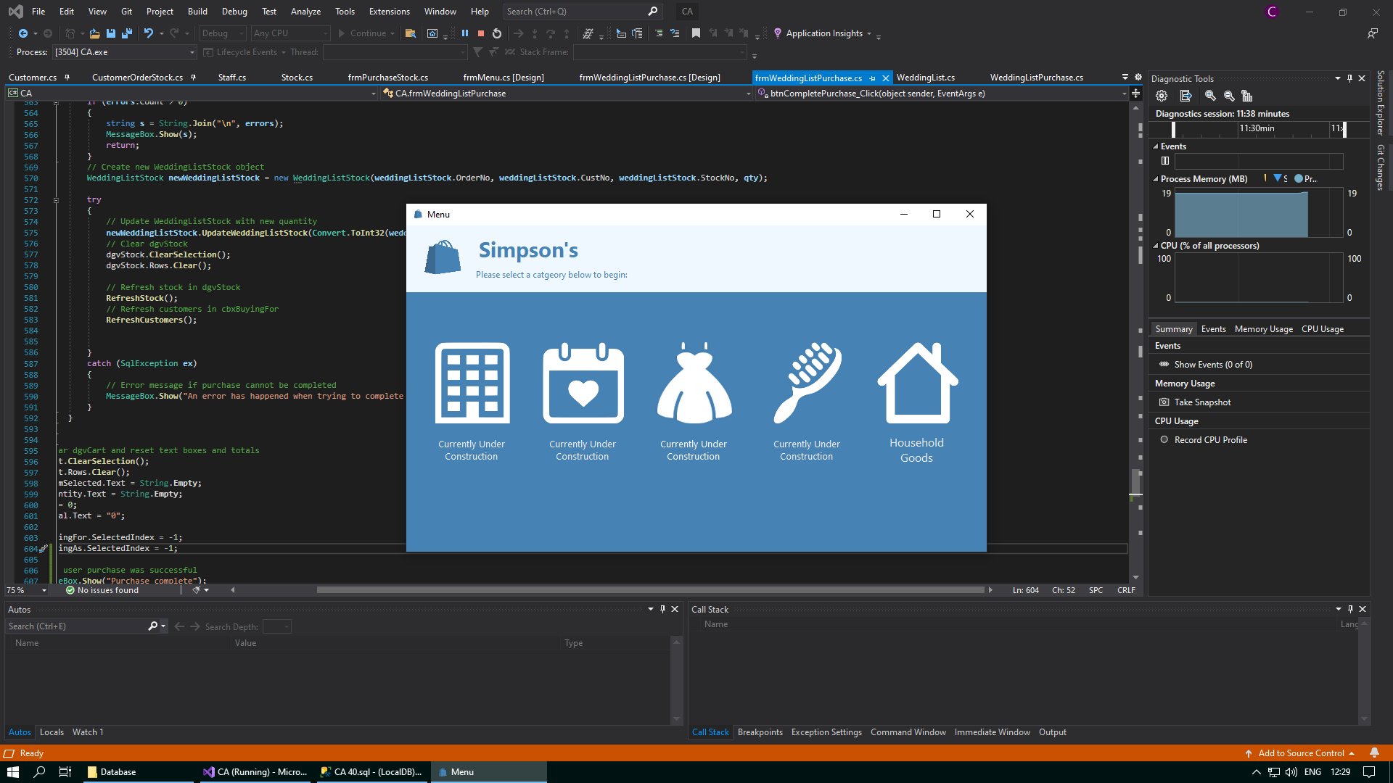

When you click on this button, you will be brought to the Welcome form. However, if you click on any of the “Currently Under Construction” buttons, you will be met with an error message. For example, if you try to access the Office and Conference Facility Rentals department:

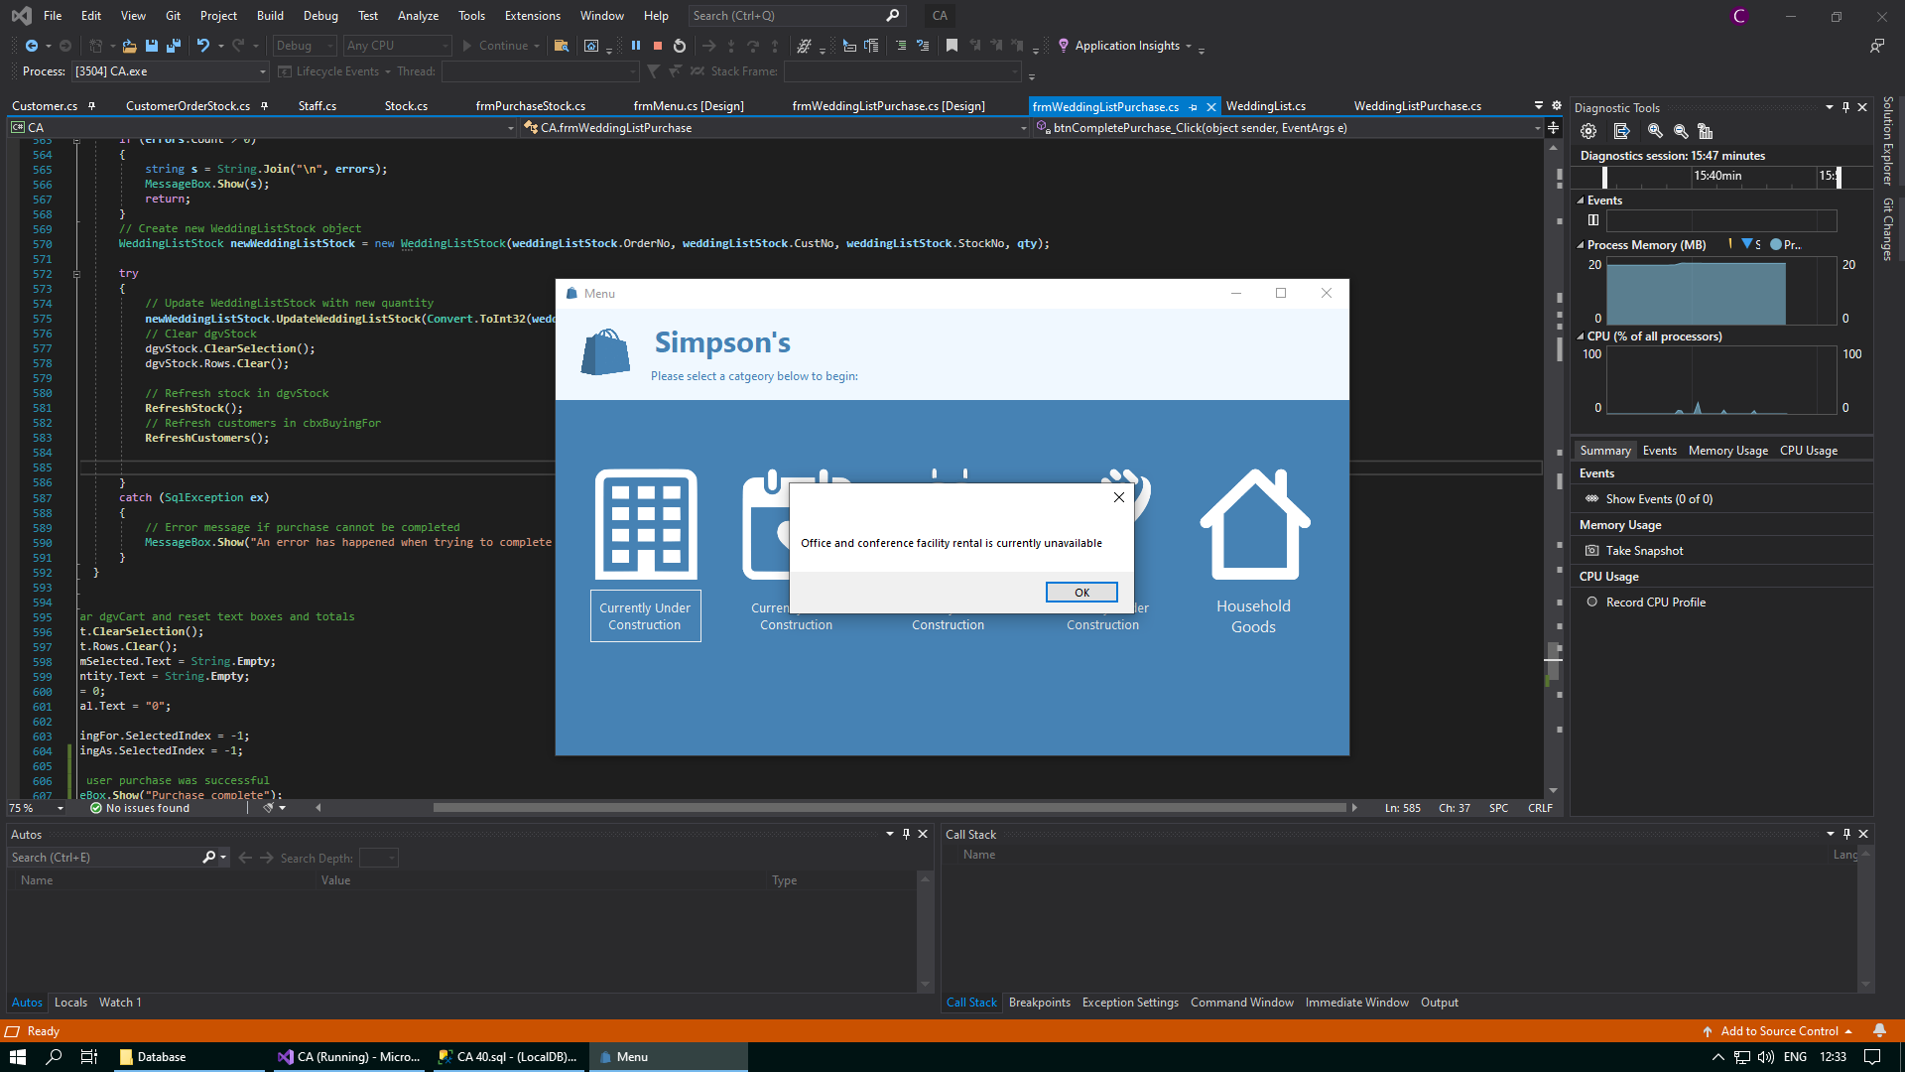

This is because these strands of the system have not yet been implemented for you to use.

## Welcome Form

Here, you can access any of the four main sections of the Household Goods department – Customers, Stock, Bookings and the Purchase from Wedding List section. If you click on any of the buttons, you will be brought to the respective section. As well, if you want to return to the Menu form, there is a “Return” button in the top left corner.

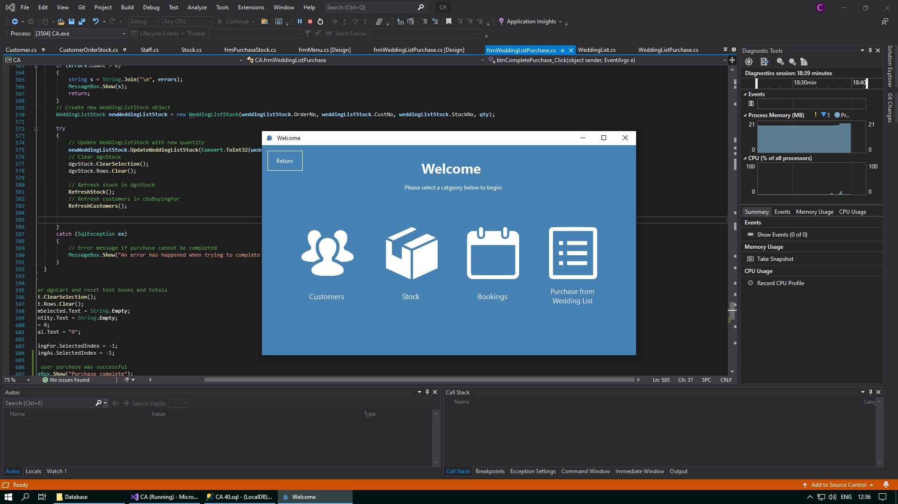

In addition, to help facilitate easier navigation between different forms, a “Return” button has been placed in the top left corner of the page to take you back to the Menu form whenever you want. You can conveniently access the Menu form again by clicking on the “Return” button situated in the top left corner of the screen.



## Customer Form

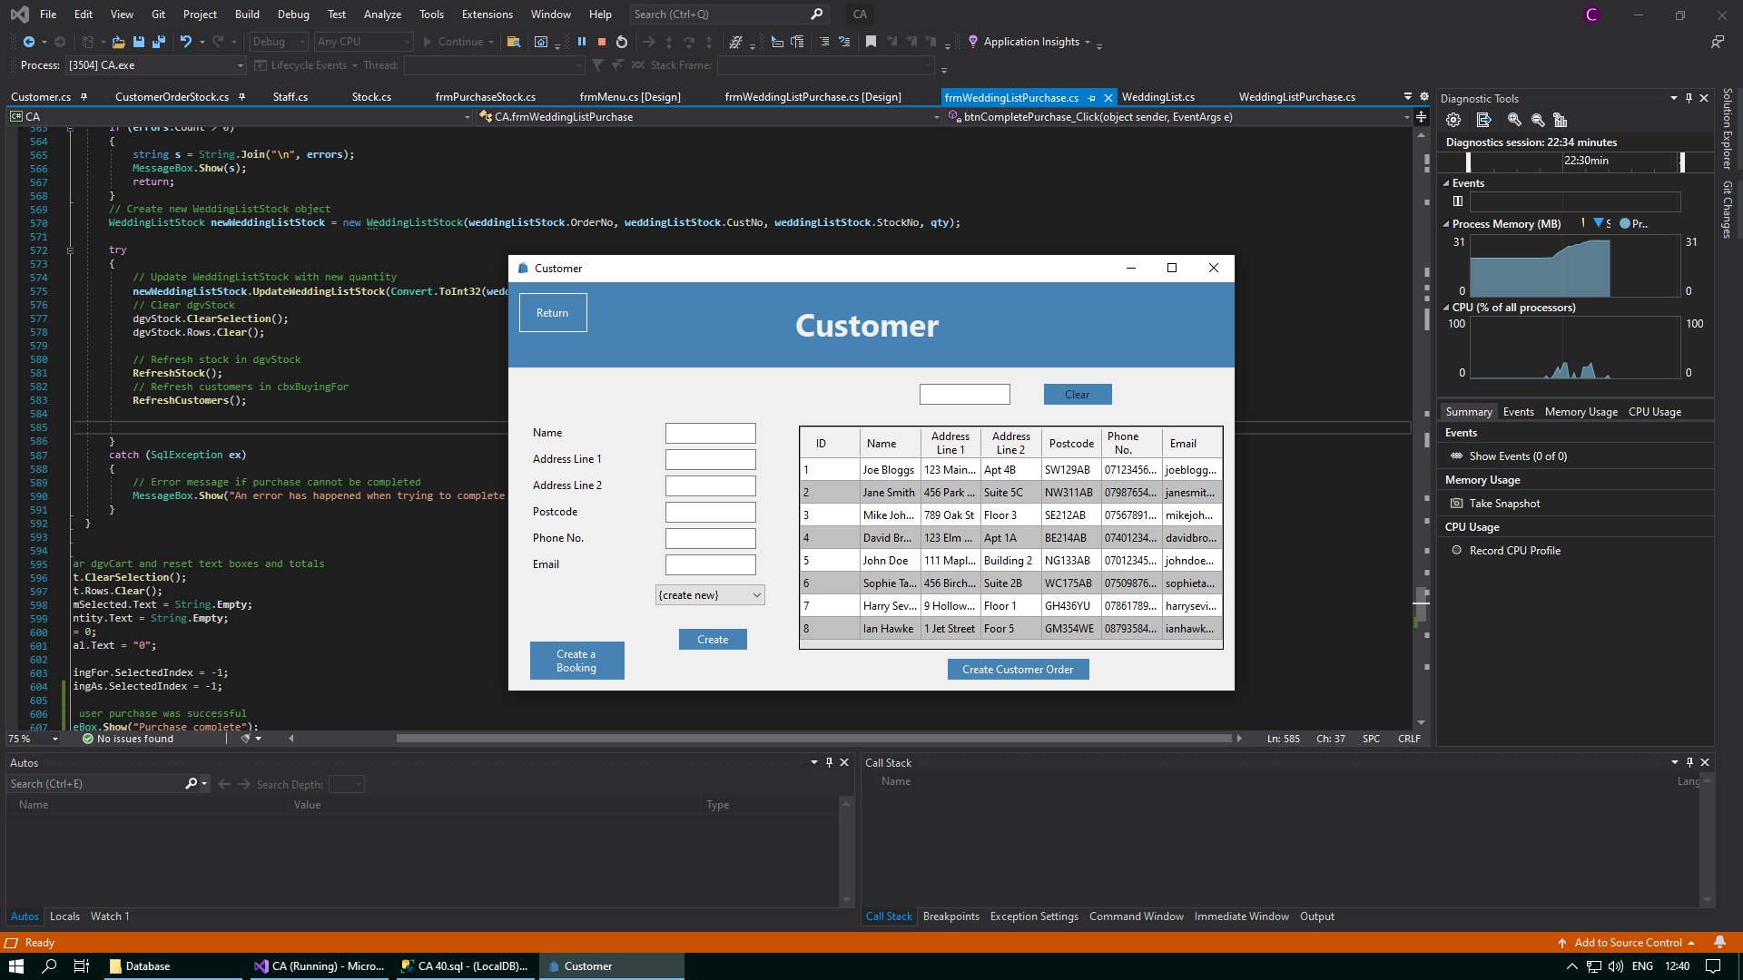The Customer form serves as a central hub for managing customer information. It can be accessed by clicking the “Customers” button in the Welcome form. Within this form, you can create new customers, view the details of existing customers, or update the details of existing customers. When you first open the form, you will be prompted to make a new customer and all text boxes will be blank.

When the form opens like above, you can enter the details for a new customer in the text boxes provided. When you want to confirm the creation of the new customer, click on the “Create” button. This will validate any information you have enetered, and if all details are correct, a new customer will be added to the Customer table in the database. To create a new customer if you have already selected a customer within the data grid view or the combo box, you must click on the combo box, and choose the first option – “{create new}” – to create a new customer.

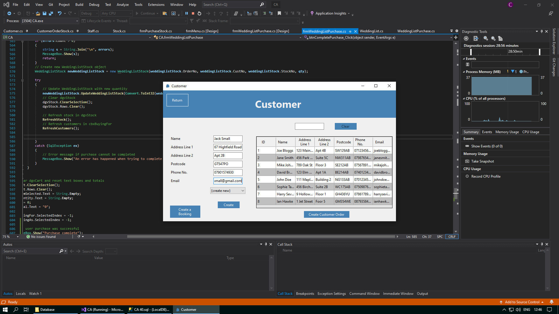

After validation is completed, any invalid data that you may have enetered will be alerted to you through a message box. This allows you to make any corrections necessary. Whenever you feel that the information you have entered is valid, you can click the “Create” button again. Below is an example of what one of these error message boxes would look like:

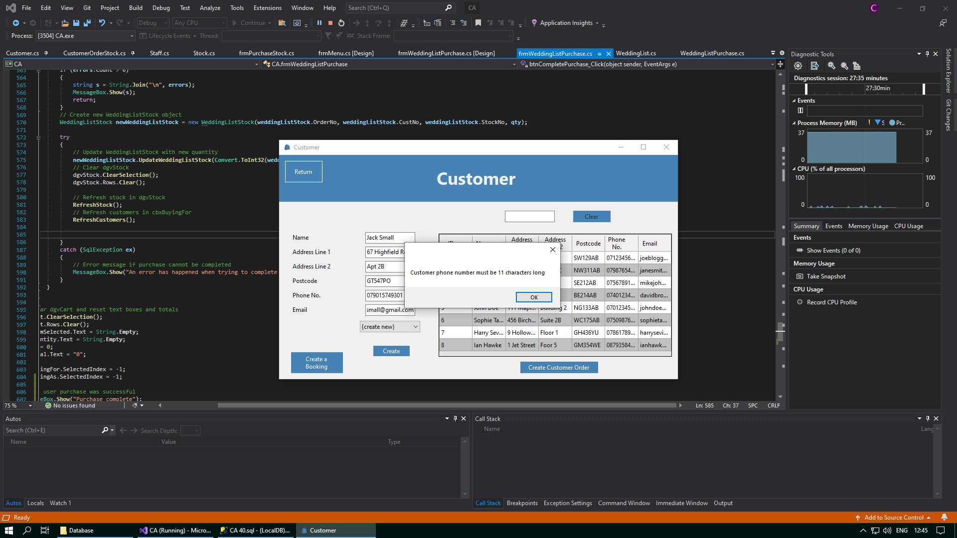

As well as being able to create a new customer, you can also select a customer and update their details. You can select a customer by either selecting them from the drop down when you click on the combo box, or you can select a customer directly by clicking on them in the data grid view. After a customer has been selected, the text boxes will be populated with this selected customer’s details. You can change any of these details, and then you can click the “Update“ button when you are done. Similar to when creating a new customer, any errors with invalid data will be highlighted to you through a message box.

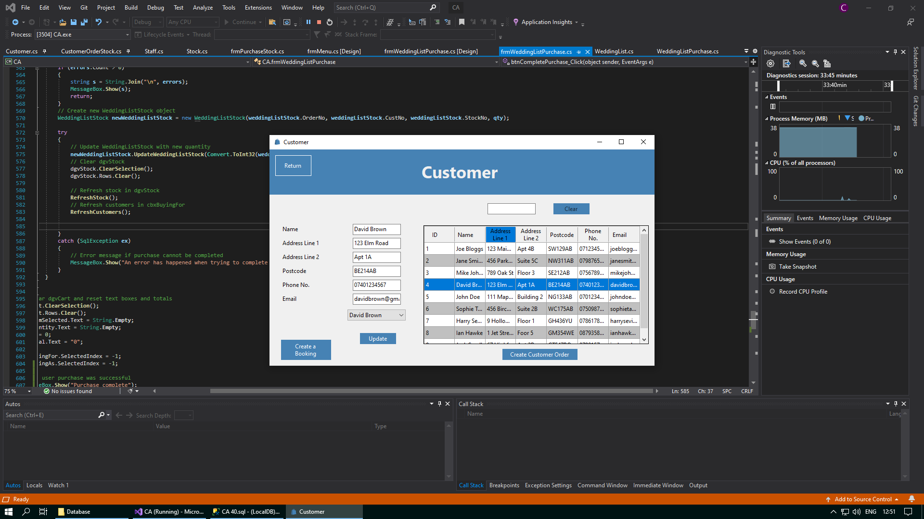



If there are many customers in the database and you do not want to have to search through all the customers in the data grid view or the combo box, then you can use the text box above the data grid view to search for the customers you need. This text box will save any input you enter as a search string, and this will be used to return any customers from the Customer table in the database with any details similar to the input you enetered.

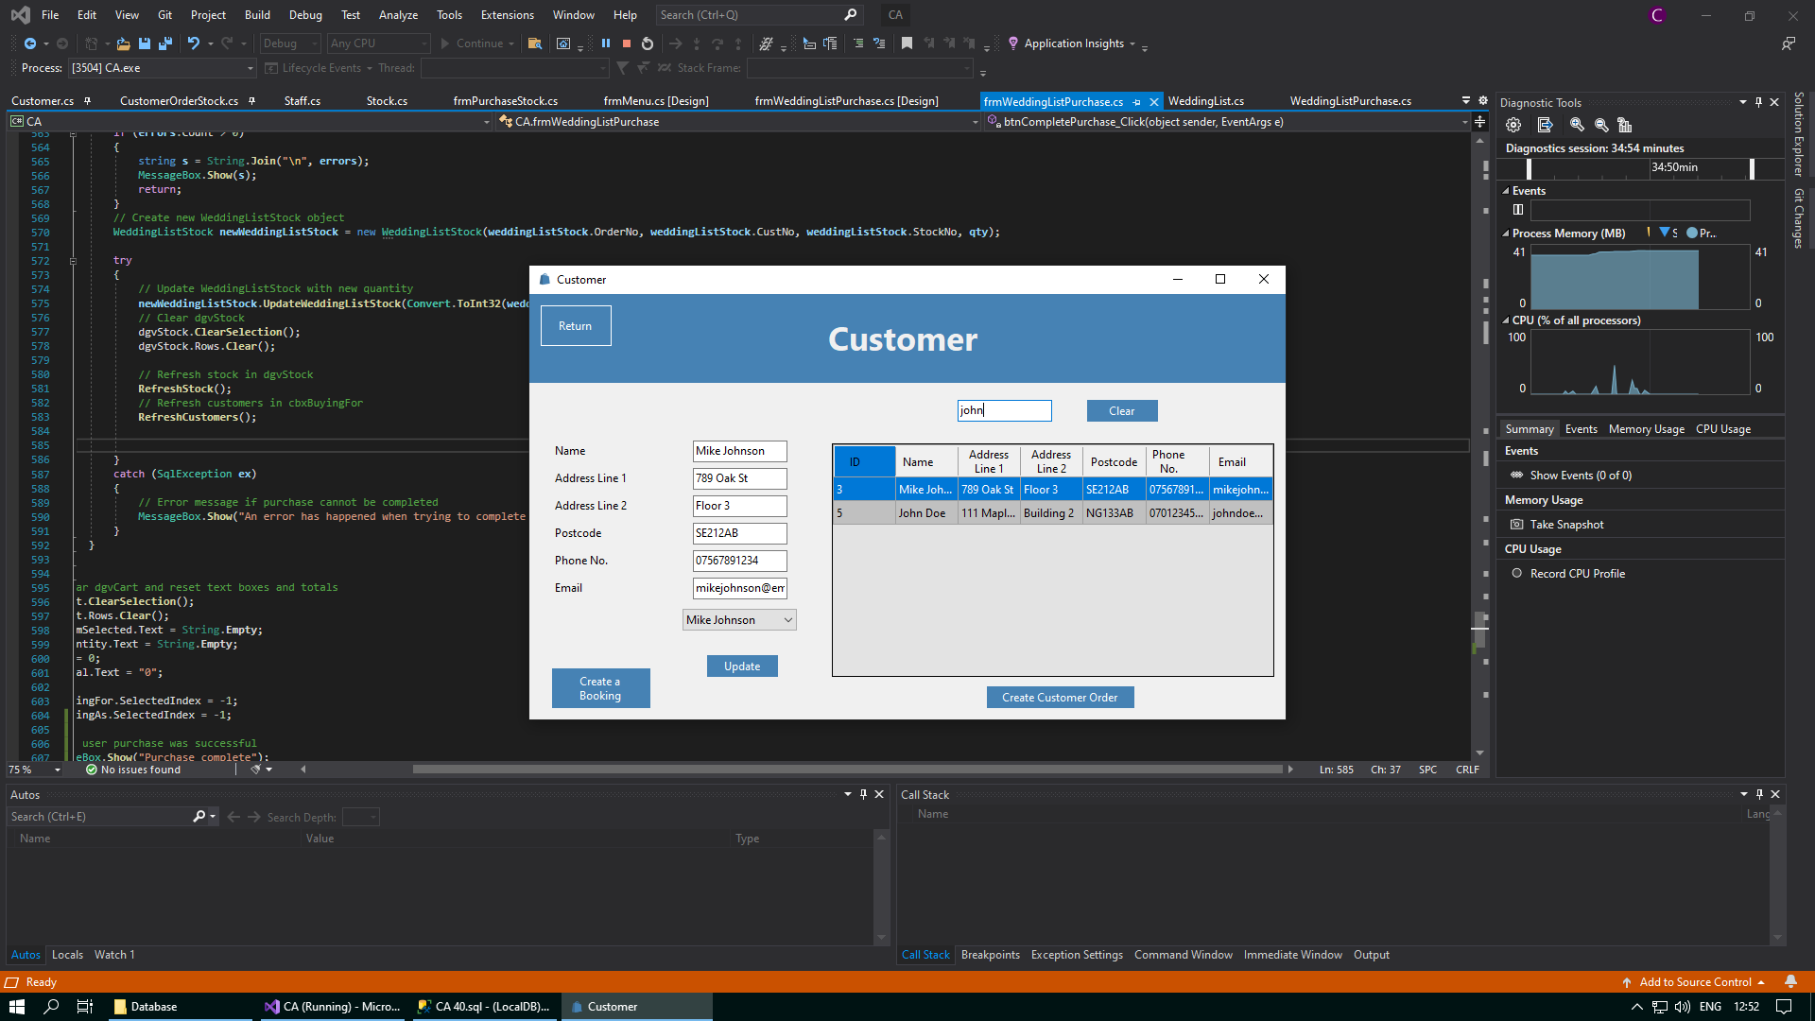



When you have finished searching for the customers that you need, you can then clear your search using the “Clear“ button. This will wipe any text you have may entered into the textbox and will show all customers from the Customer table in the data grid view again.

In addition to being able to update customers with new details, selecting a customer gives you the choice to either create a booking for them, or create a customer order for them. A booking will be a selected appointment on a particular date at a particular time for a couple to visit the department in Simpson’s, and make their wedding list. A customer order is a record of the details of an order made by a customer for the purchase of stock. If you click the “Create a Booking” button, the user will be brought to the Booking form, assumoing that the selected customer has not already made a booking yet.





If you click on the “Create a Booking” button and the customer has already made a booking, then you will be prevented from being directed to the Booking form. Instead, you will be met with the following error message:

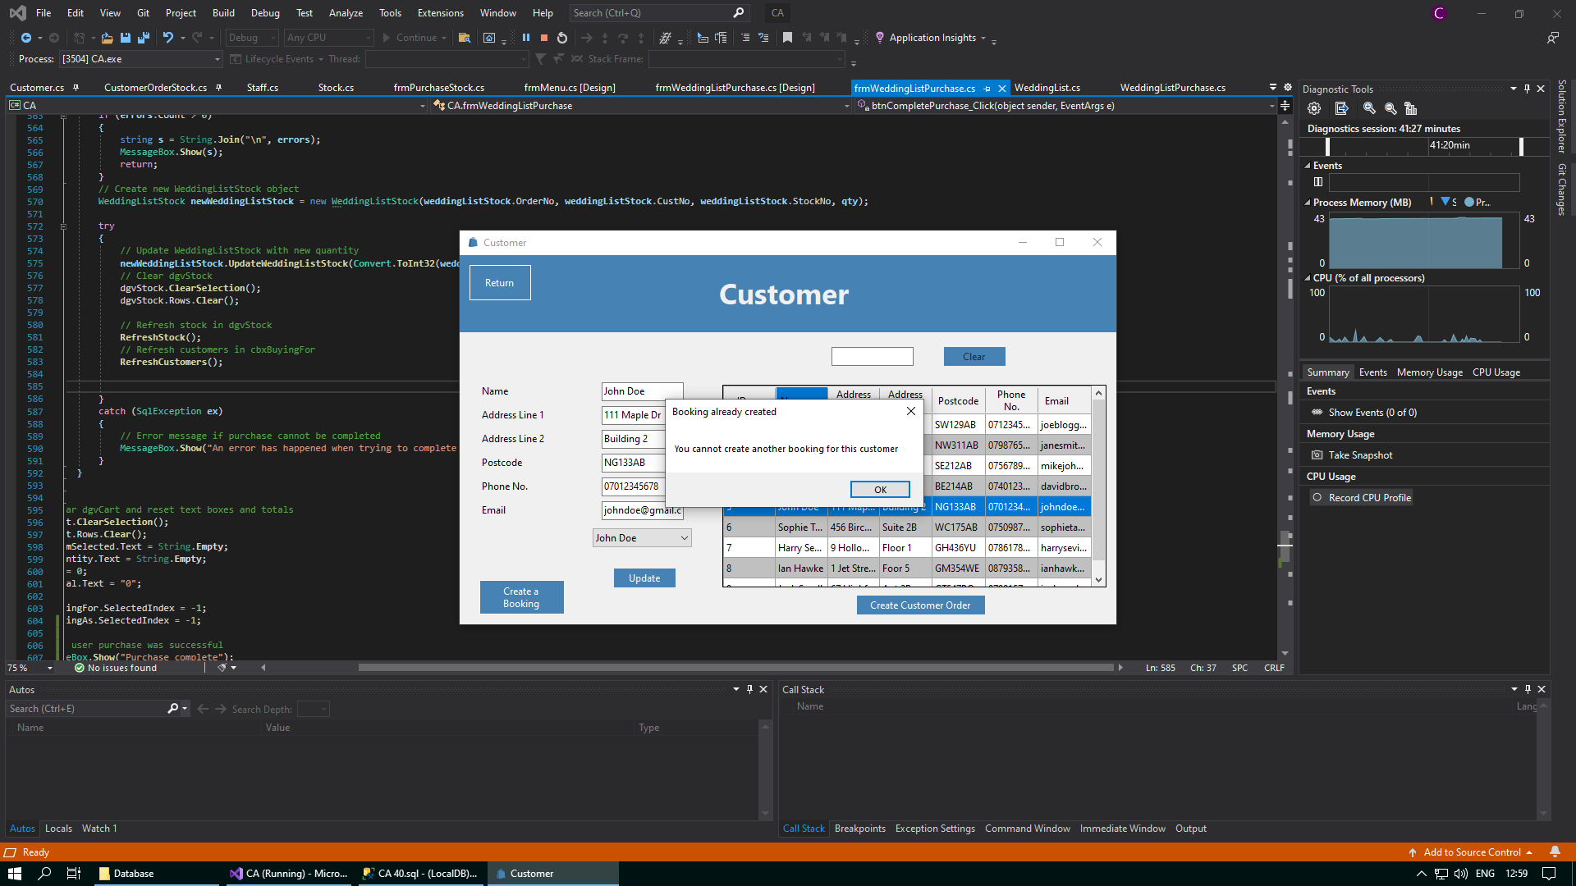

If you select a customer and then you click on the “Create Customer Order” button, the following message box will be displayed. You will not be automatically be brought to the Purchase Stock form. If you want to now purchase stock for this customer, you will have to reselect this customer from either the combo box or the data grid view and click on this button again, which will now say “Purchase Stock” instead of “Create Customer Order”. It is important to note that when trying to create a new customer order and go directly to the Purchase Stock form in one click, the details for the new customer order may not be passed over. Therefore, it is necessary to create the customer order first and then select the customer again to purchase stock. For a more detailed explanation on this, please visit the Further Help/FAQ setion of this document.

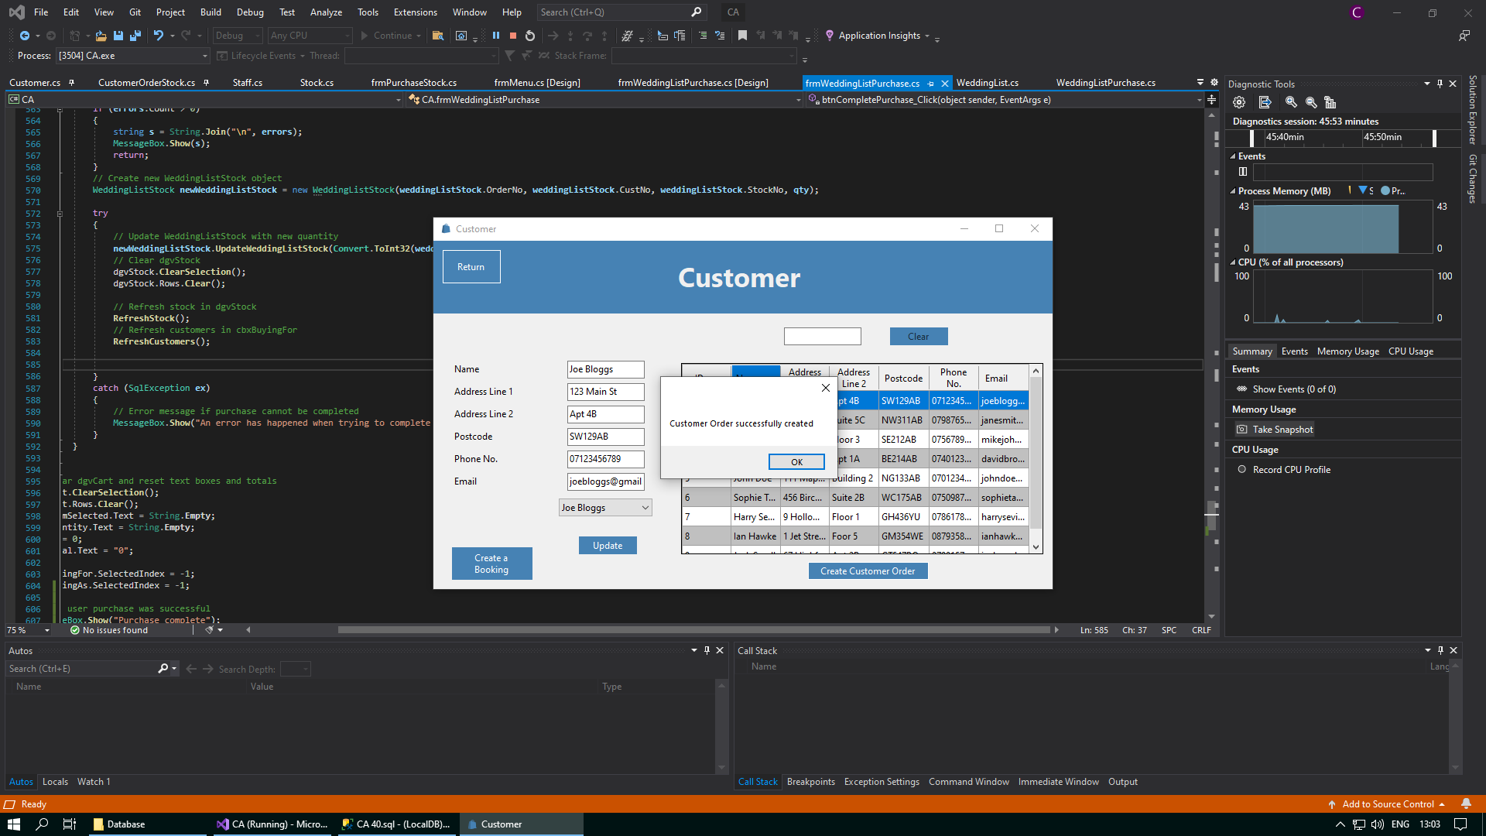

Here is an example of what this button will now look like after a customer order has been made for a customer, and this customer is reselected from either the data grid view or the combo box. When you click on this button, you will be brought to the Purchase Stock form, where you can now purchase stock for this customer.

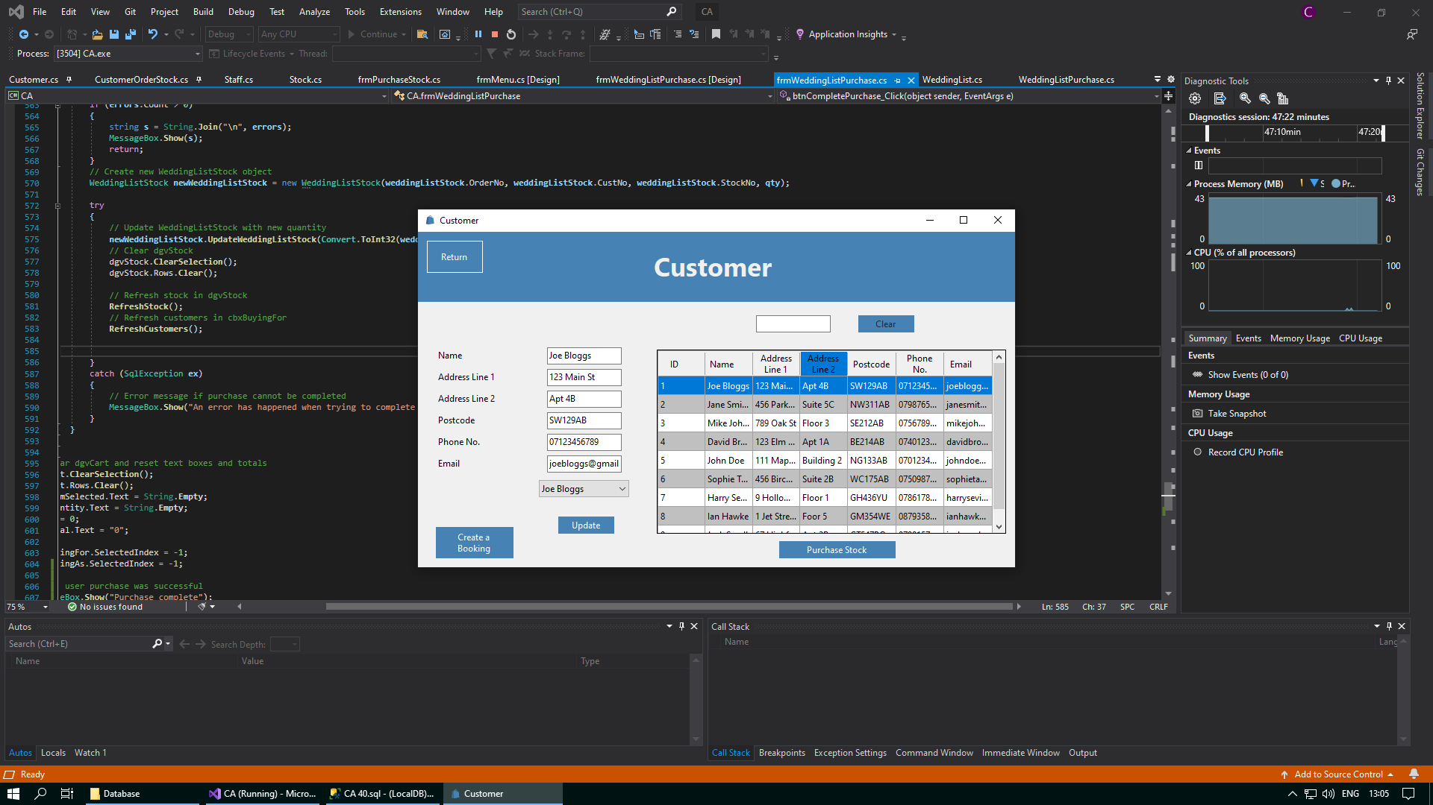



In addition, to help facilitate easier navigation between different forms, a “Return” button has been placed in the top left corner of the page to take you back to the Welcome form whenever you want. You can conveniently access the Welcome form again by clicking on the “Return” button situated in the top left corner of the screen.





## Booking Form

The Booking form helps to facilitate you in making a booking for the customer that you selected in the Customer from. You can book for any date, starting from tomorrow onwards. After you select a date for the booking, you can select a time slot which will also automatically assign a member of staff from the Households Goods department to help facilitate with the appointment on the day.

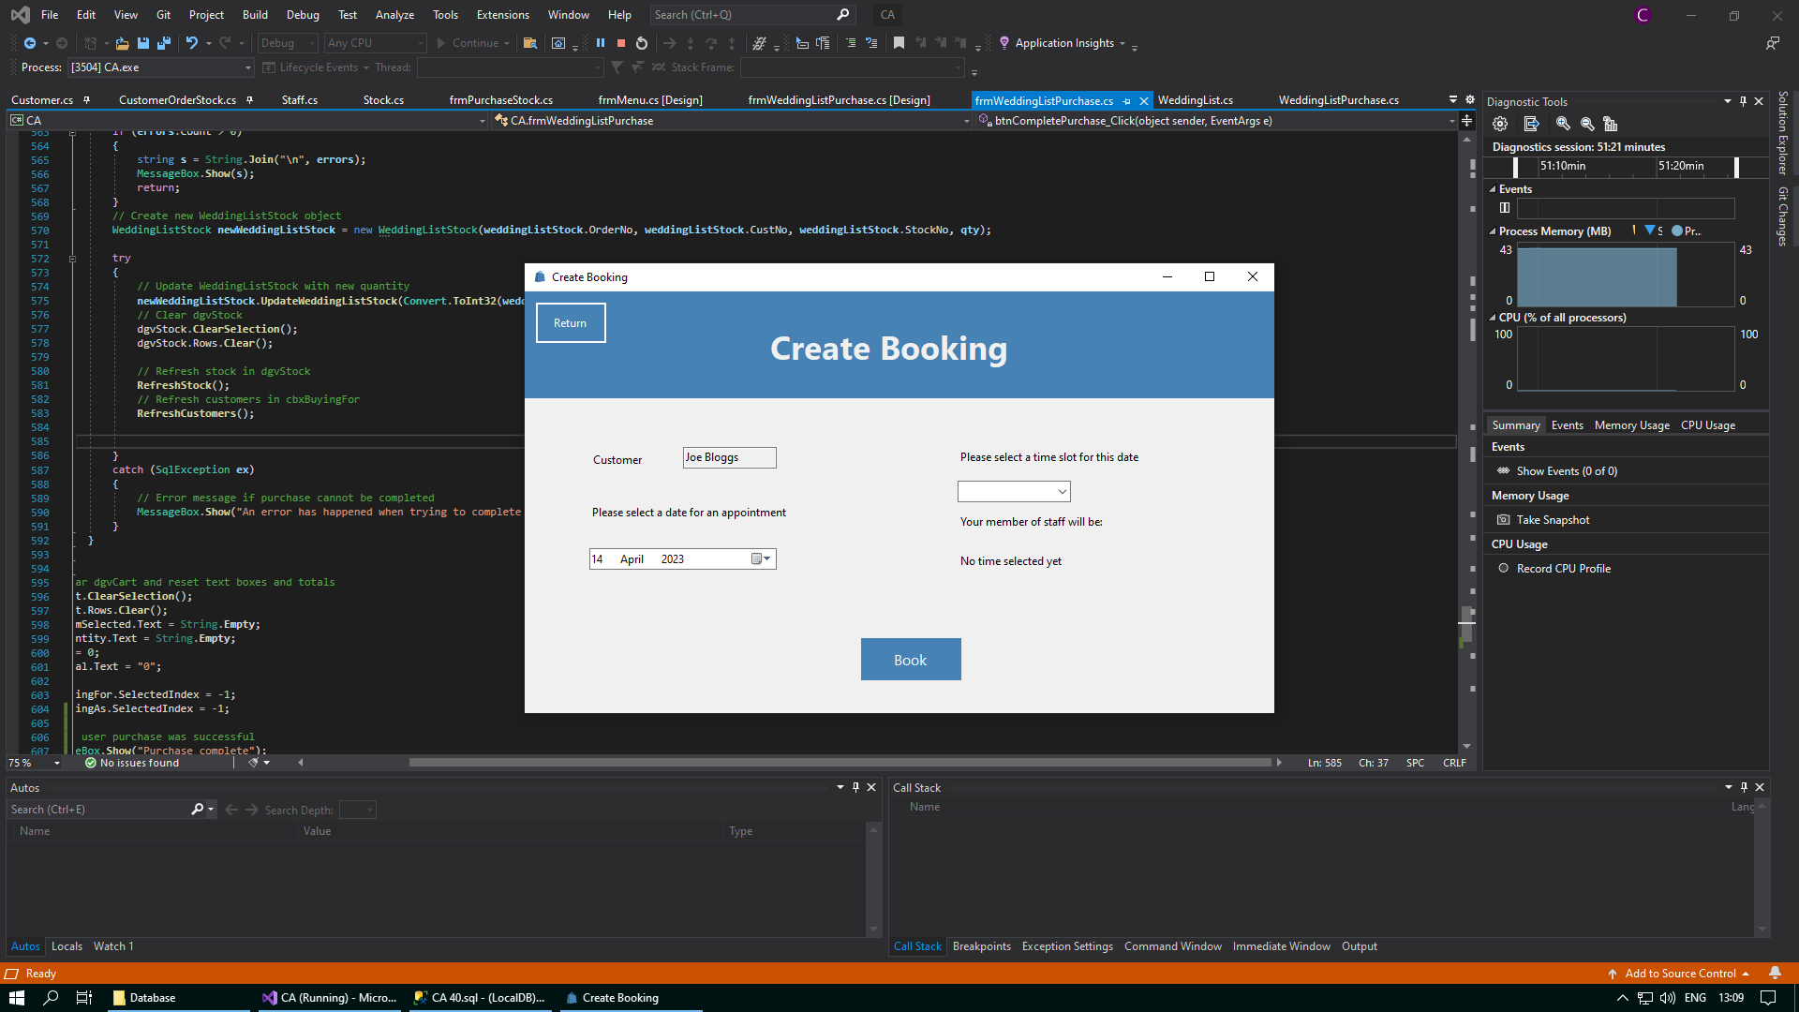

You can select the date you want to make the booking for by clicking on the date time picker and selecting a date from the drop down. When you open the form, the closest available date will be already assigned for the booking. However, you can change this and select the date that the customer would like to make a booking for.



If you choose a date, or use the default date, and then proceed to try to create a booking without a time, the following error message will be displayed:

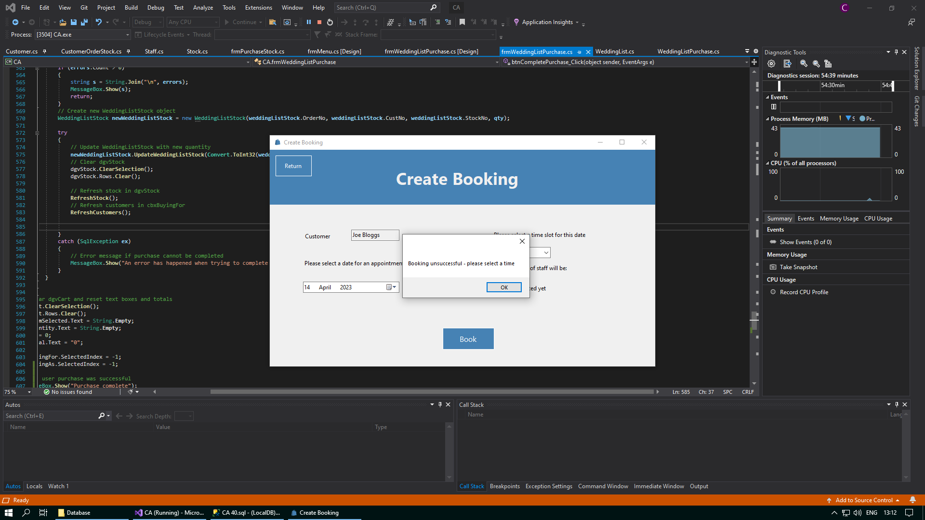

To prevent double bookings for the same time on the same day, only time slots that have a member of staff available to assist and no bookings already made for this time will be displayed in the drop down for the combo box. Whenever you select the time for the booking, a member of staff will be automatically assigned to assist the customer on the day.

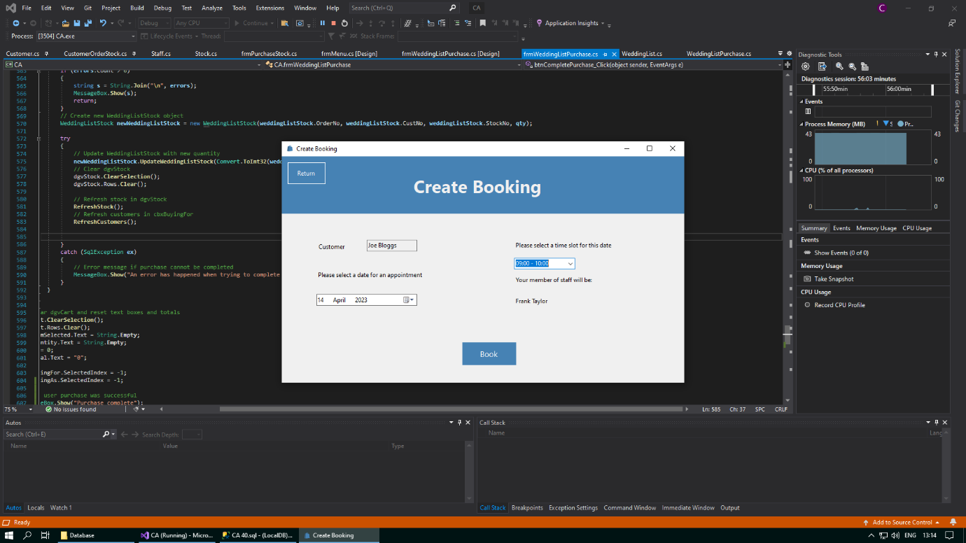

After you select a time and have a member of staff assisted to help out with the booking, you can then click the “Book” button at the bottom of the form. This will display the following message box to tell you that the booking you have made for this customer has been successful:

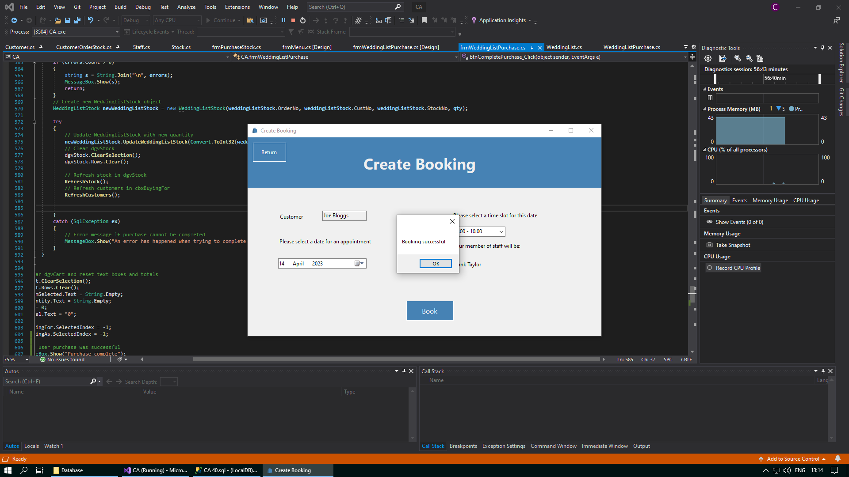

After a booking has been successfully made, the “Book” button will become disabled to prevent you from making a second booking for the same customer, and then you will be forced to exit the form using the “Return” button. This button is situated in the top left corner of the screen, and this will return you to the Customer form when you click on it. As well, this button can also be used to cancel a booking if clicked on before a booking has been successfully made. You can reselect this customer in the Customer form at any time and click the “Create a Booking” button if you want to try to make a booking for this customer again. For more information, please visit the Further Help/FAQ section of this document.

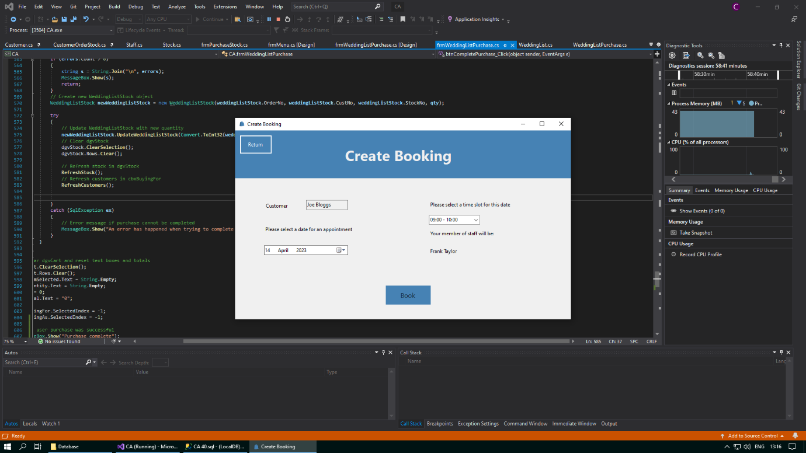

## Purchase Stock Form

Whenever you make a customer order for a customer in the Customer form, you can now visit this form whenever you select this customer, so that you can purchase stock for this customer. In this form can select stock from the data grid view, choose the quantity that you would like to order for this customer, and then add it to your cart for purchase for this customer. You can add as many items as you like to the cart.

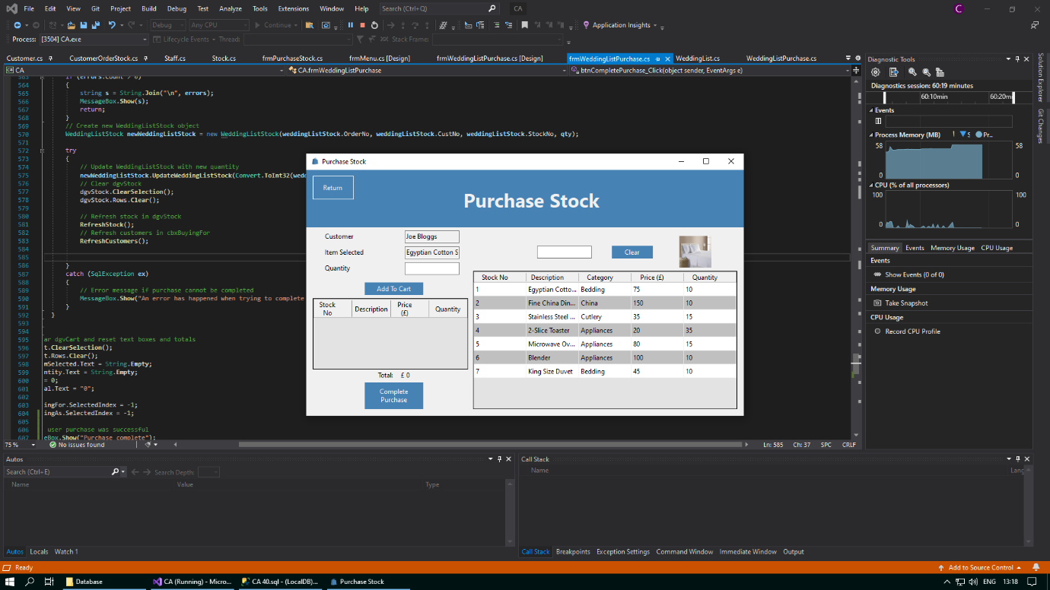

If you accidentally click the “Complete Purchase” button without adding any stock to the cart for purchase for the customer, you will get the following error message:

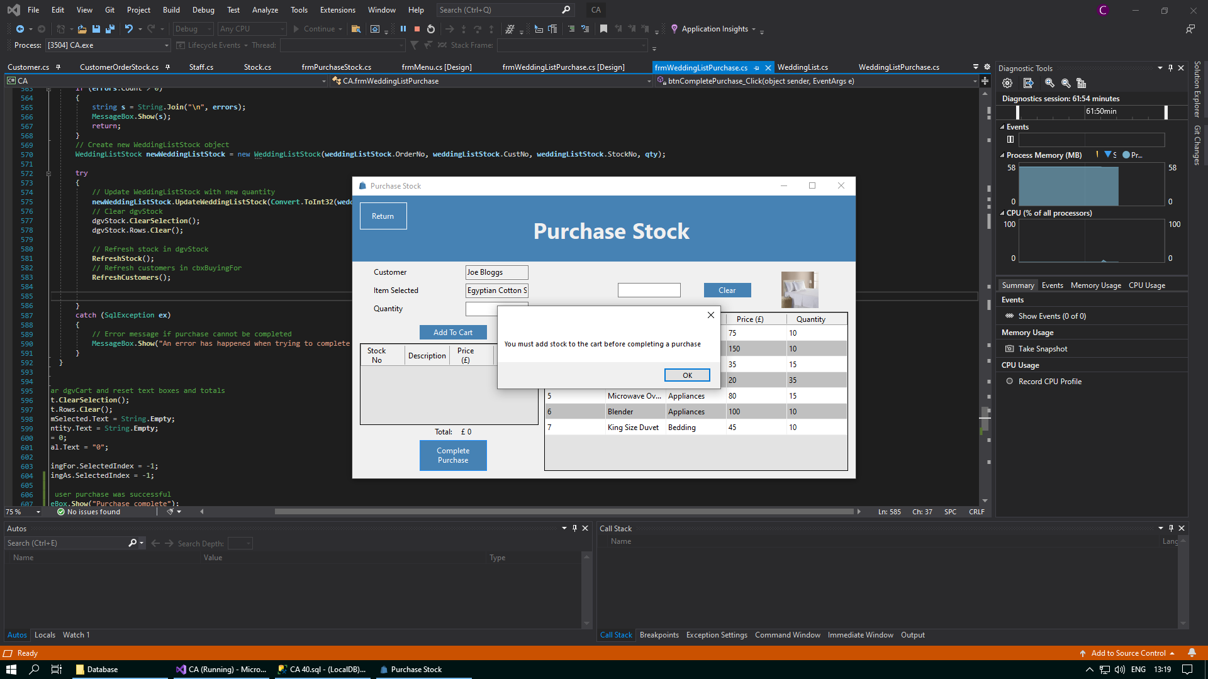

As well as this, if you select an item of stock and do not choose a quantity to add to the cart, and then you click the “Add To Cart” button, you will also get the following error message:

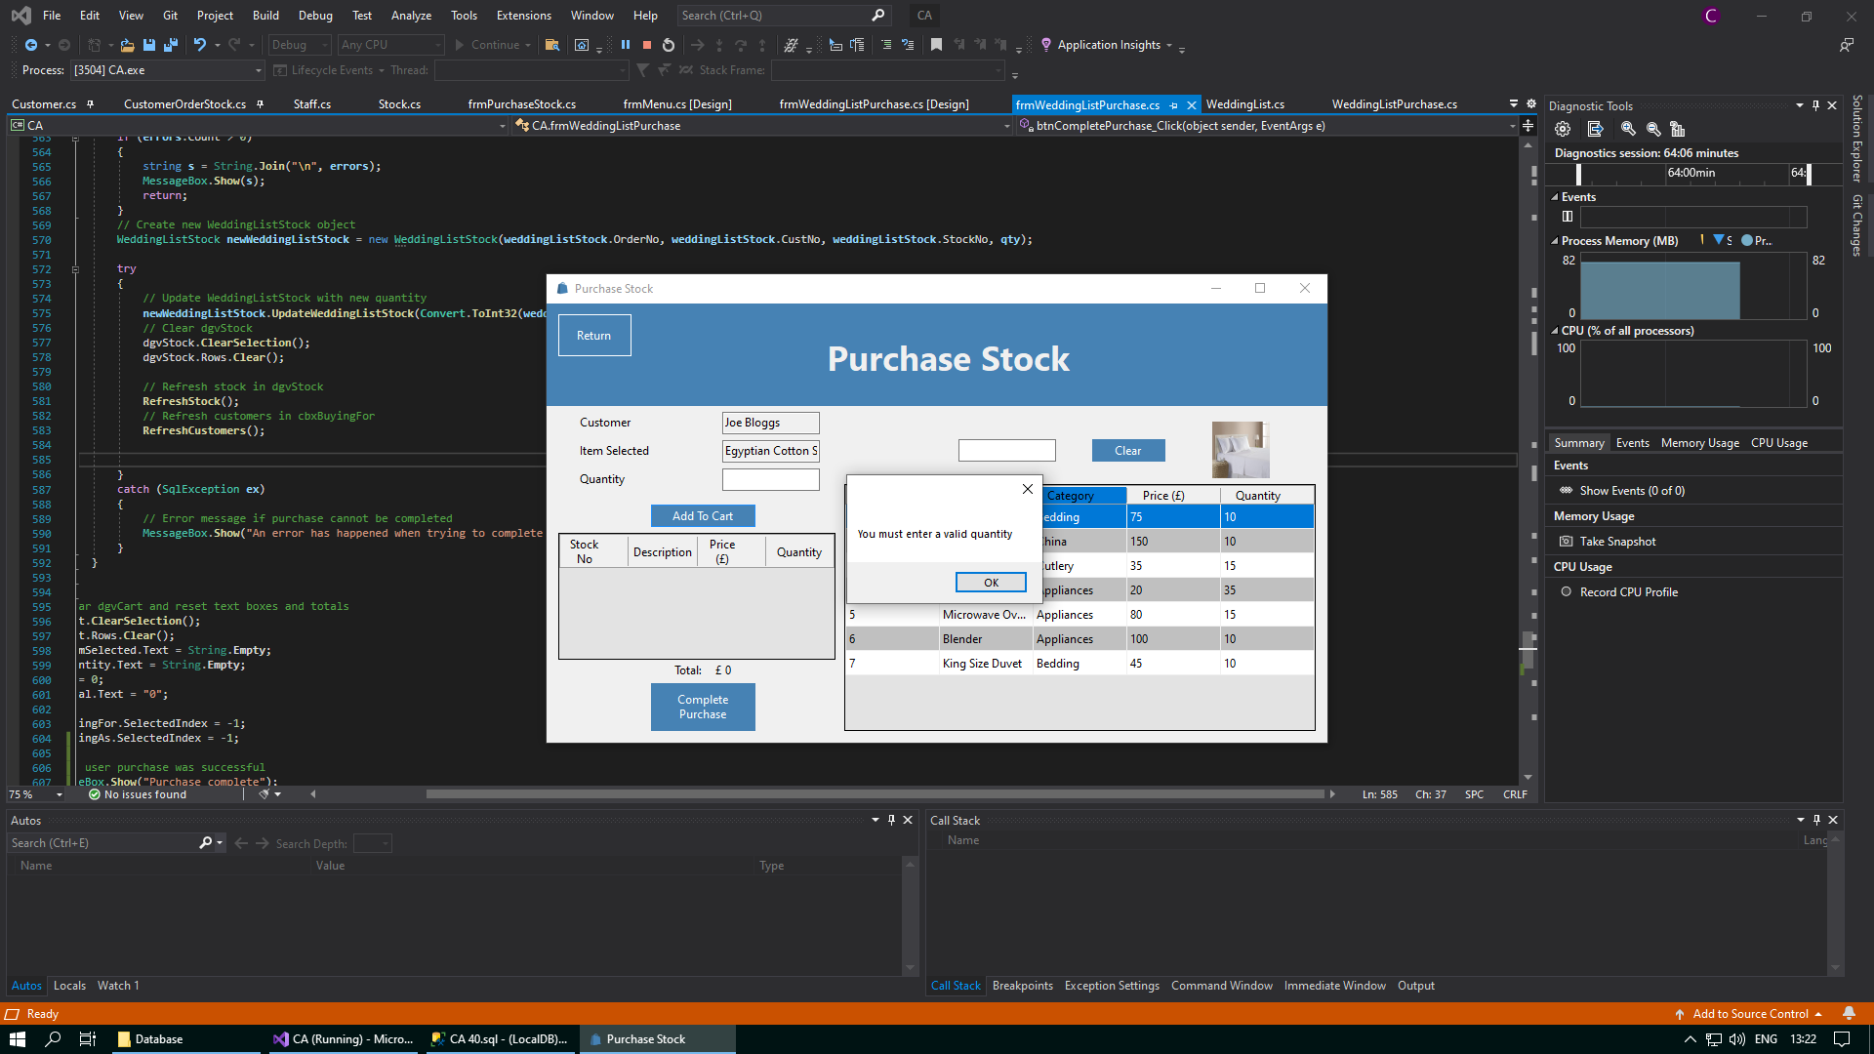

When you enter a chosen quantity into the text box, you can then add the selected stock to the cart by clicking the “Add To Cart” button. The item(s) of stock will be successfully added to the cart, and you can then either select new items to add to the cart, or you can choose to complete the purchase for the customer.

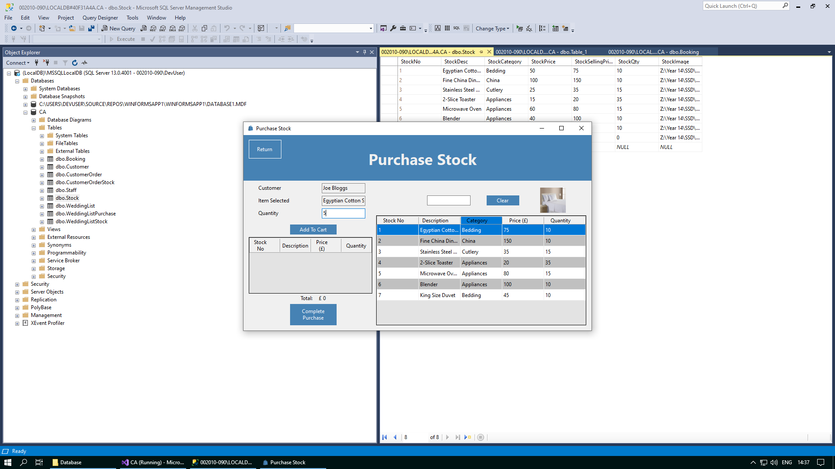

Whenever you have added all the stock to the cart that you would like to purchase for the selected customer, you can then confirm this purchase by clicking on the “Complete Purchase” button that sits below the cart.

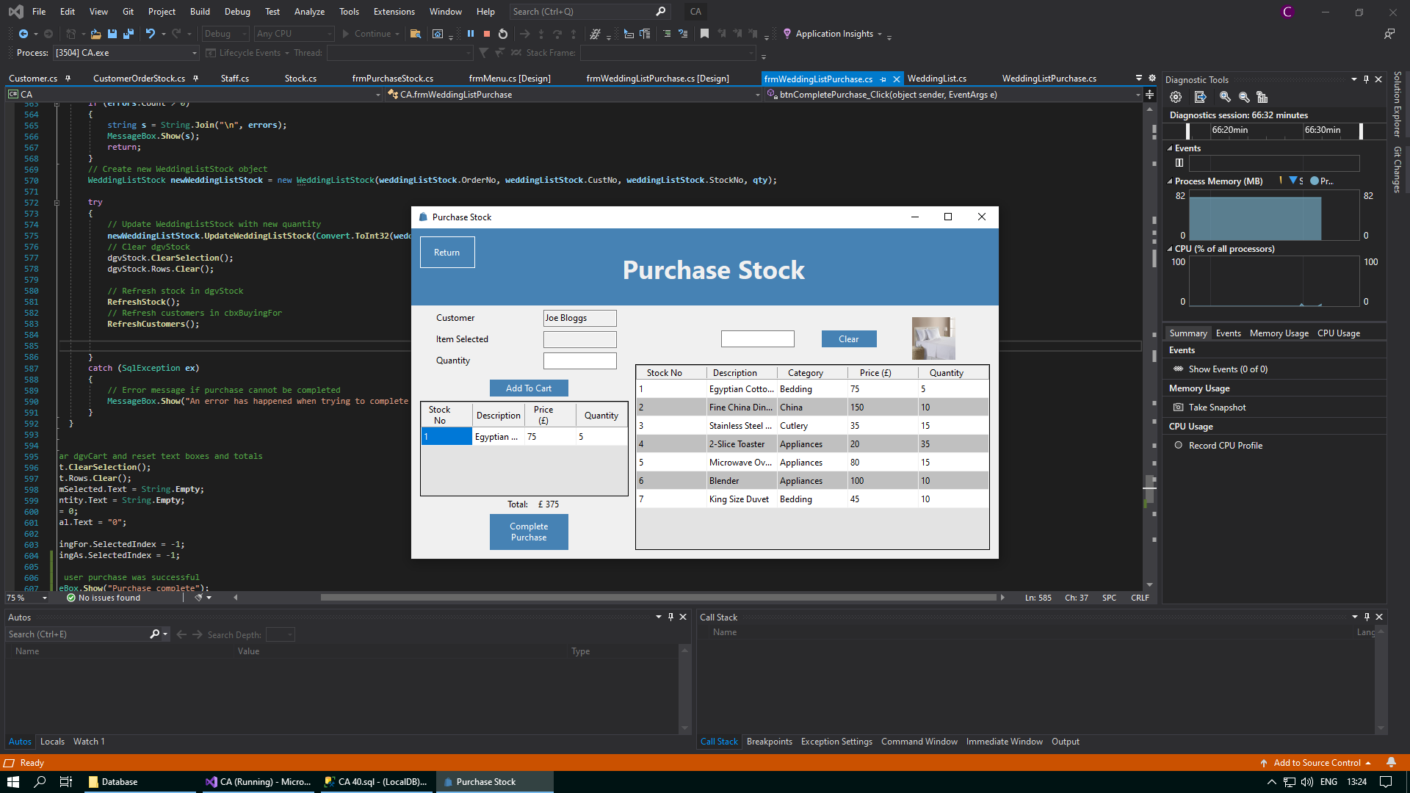

Whenever you have completed purchasing stock for the selected customer, you can then exit the form using the “Return” button. This will take you back to the Customer form, where you can choose to create a customer order for other customers. If you have forgotten to purchase any stock items for the customer, you can reselect them from the data grid view in the Customer form, and select the “Purchase Stock” button again to return to this form.

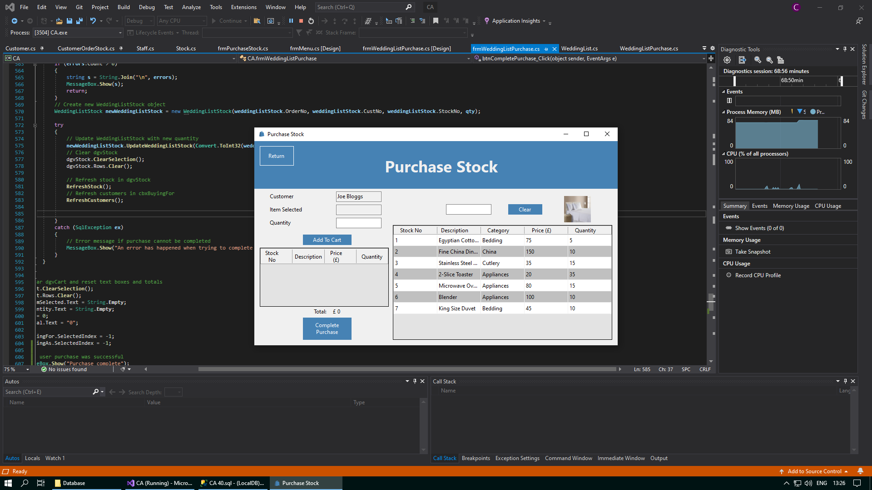

If there are many items of stock in the database and you do not want to have to search through all the stock in the data grid view, then you can use the text box above the data grid view to search for the stock you need. This text box will save any input you enter as a search string, and this will be used to return any items of stock from the Stock table in the database with any details similar to the input you enetered.

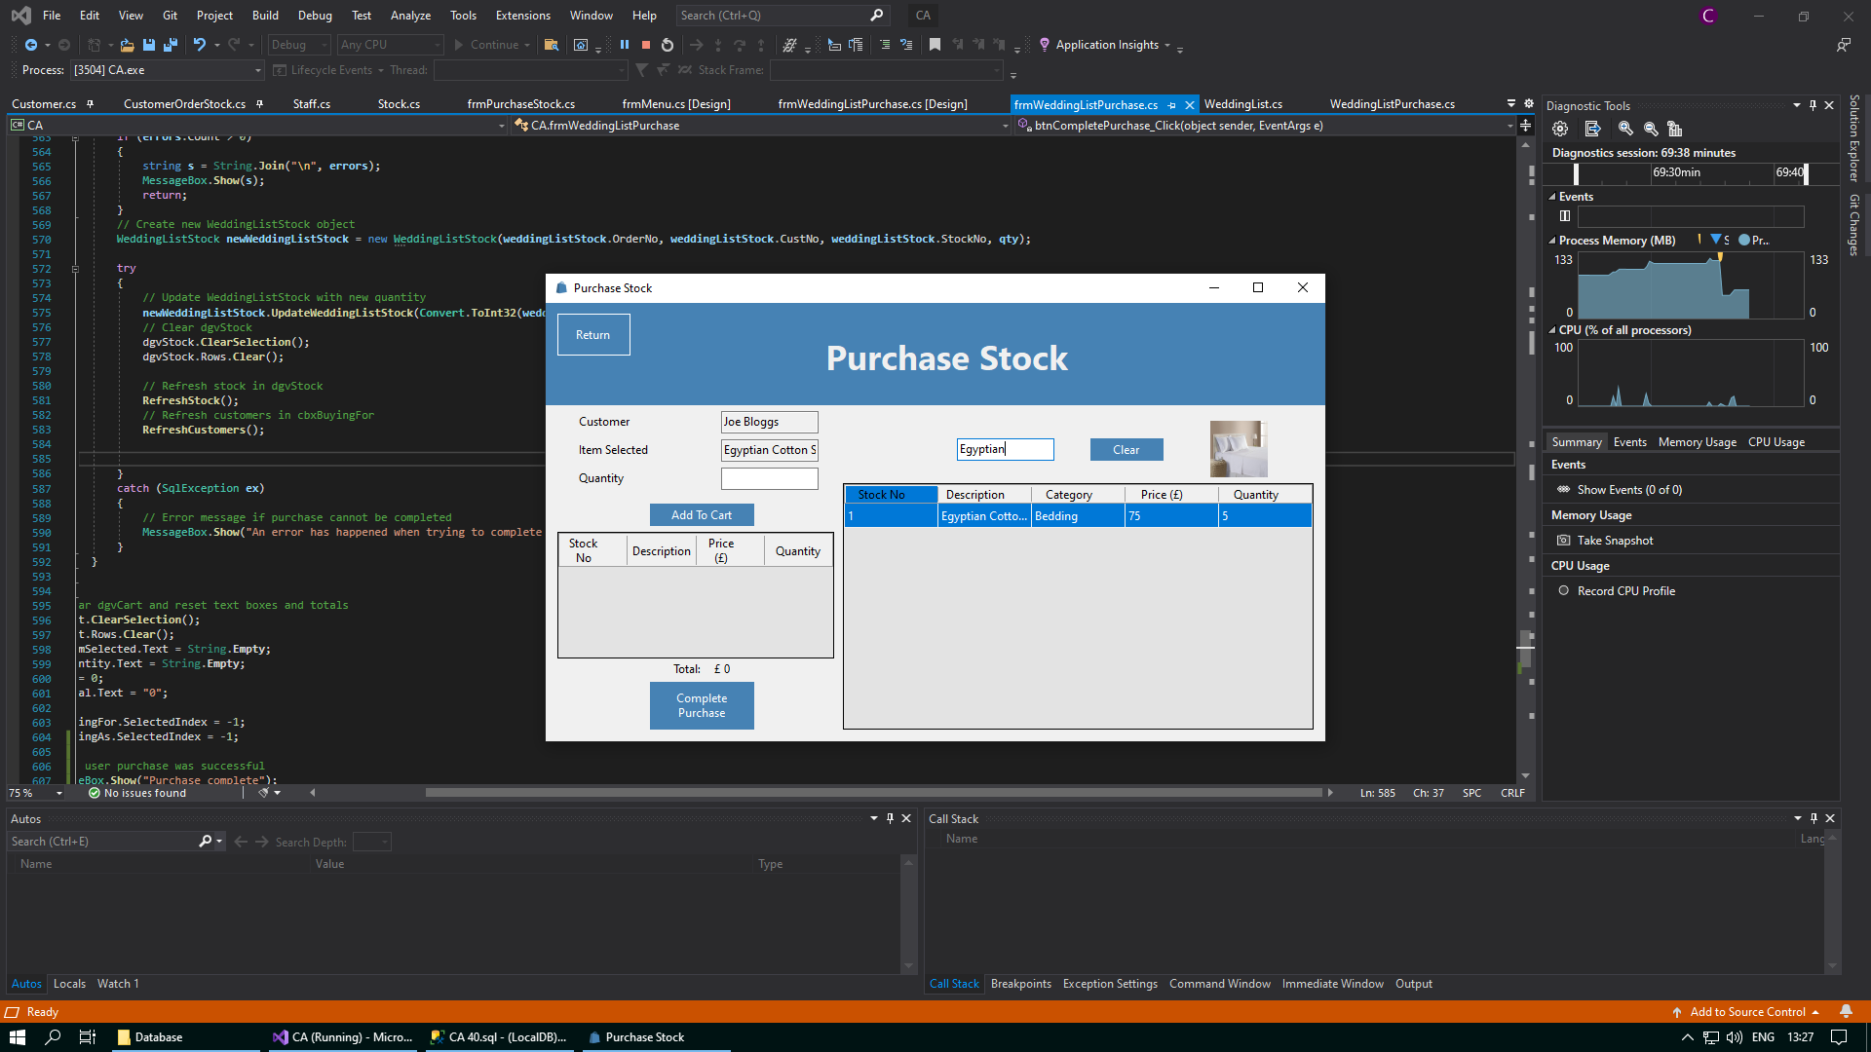



When you have finished searching for the items of stock that you need, you can then clear your search using the “Clear” button. This will wipe any text you have may entered into the textbox and will show all stock from the Stock table in the data grid view again.

## Stock Form

The Stock form serves as a central hub for managing stock information. It can be accessed by clicking the “Stock” button in the Welcome form. Within this form, you can create new items of stock, view the details of existing items of stock, or update the details of existing items of stock. When you first open the form, you will be prompted to make a new item of stock and all text boxes will be blank.

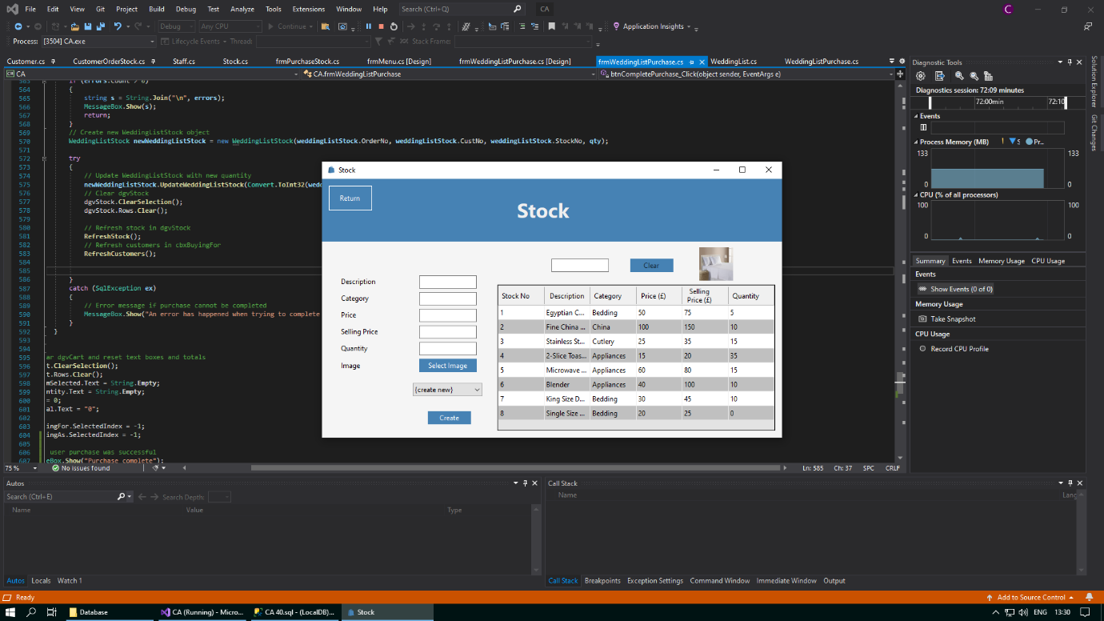

When the form opens like above, you can enter the details for a new item of stock in the text boxes provided. When you want to confirm the creation of the new item of stock, click on the “Create” button. This will validate any information you have enetered, and if all details are correct, a new item of stock will be added to the Stock table in the database. To create a new item of stock if you have already selected a customer within the data grid view or the combo box, you must click on the combo box, and choose the first option – “{create new}” – to create a new item of stock.

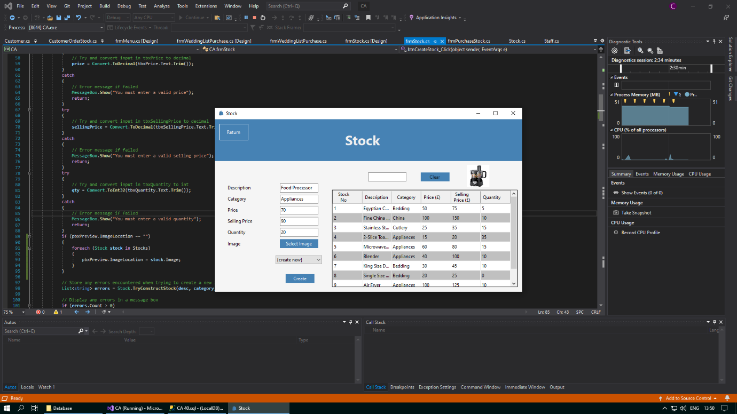

After validation is completed, any invalid data that you may have enetered will be alerted to you through a message box. This allows you to make any corrections necessary. Whenever you feel that the information you have entered is valid, you can click the “Create” button again. Below is an example of what one of these error message boxes would look like:

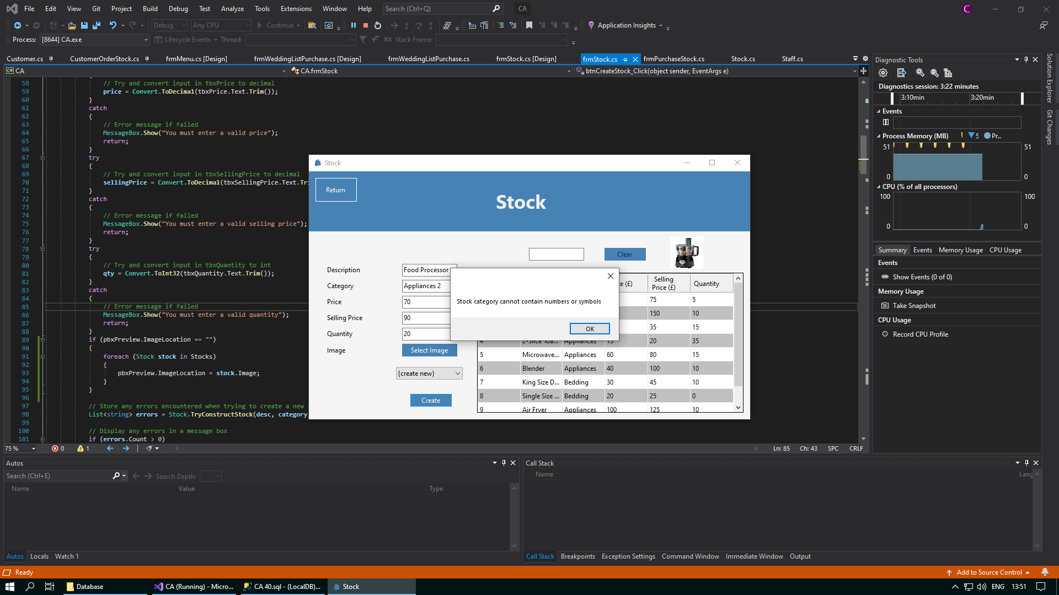

As well as being able to create a new item of stock, you can also select an item of stock and update its details. You can select select by either selecting it from the drop down when you click on the combo box, or you can select stock directly by clicking on them in the data grid view. After an item of stock has been selected, the text boxes will be populated with this selected stock’s details. You can change any of these details, and then you can click the “Update” button when you are done. Similar to when creating a new item of stock, any errors with invalid data will be highlighted to you through a message box.

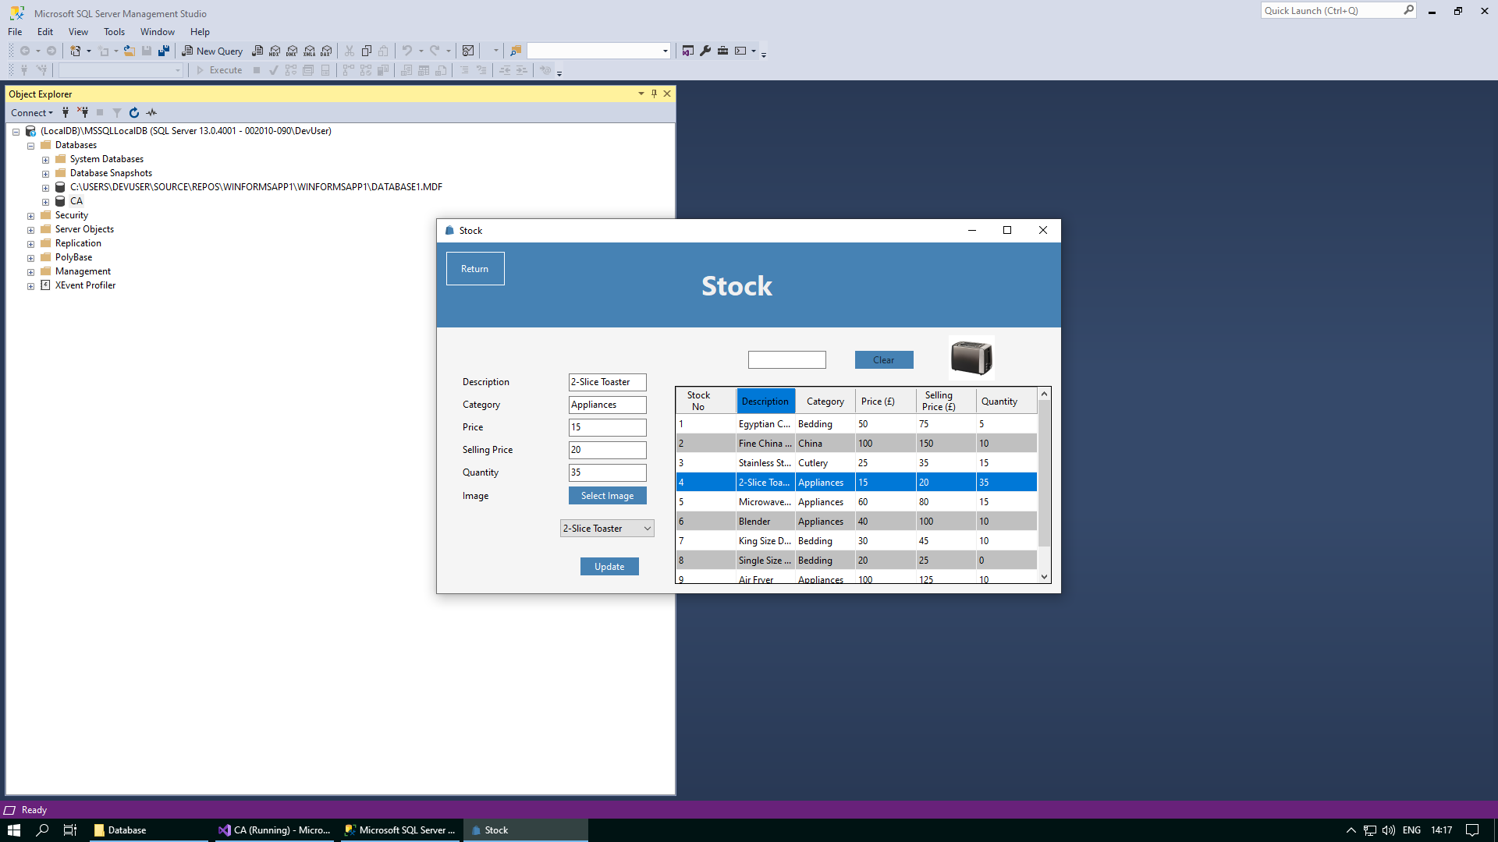

If there are many items of stock in the database and you do not want to have to search through all the stock in the data grid view or the combo box, then you can use the text box above the data grid view to search for the stock you need. This text box will save any input you enter as a search string, and this will be used to return any items of stock from the Stock table in the database with any details similar to the input you enetered.

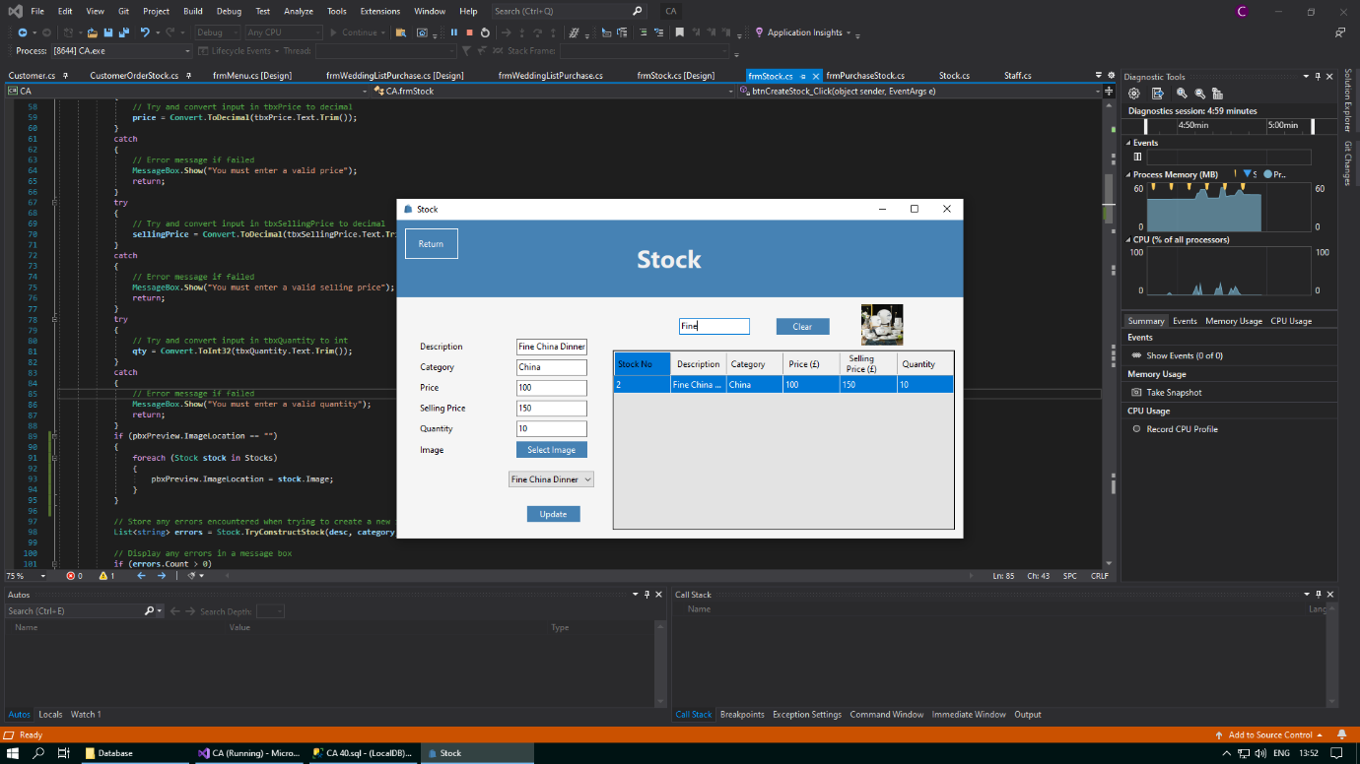

When you have finished searching for the items of stock that you need, you can then clear your search using the “Clear” button. This will wipe any text you have may entered into the textbox and will show all stock from the Stock table in the data grid view again.

In addition, to help facilitate easier navigation between different forms, a “Return” button has been placed in the top left corner of the page to take you back to the Welcome form whenever you want. You can conveniently access the Welcome form again by clicking on the “Return” button situated in the top left corner of the screen.



## View Bookings Form

The View Bookings form allows you to choose a date, view the bookings made for this date, and create a wedding list for a selected customer. When you open the View Bookings form, you can see the customers that have made a booking for today. If there are no customer that have made a booking for today, the “Create Wedding List” button will not be visible.

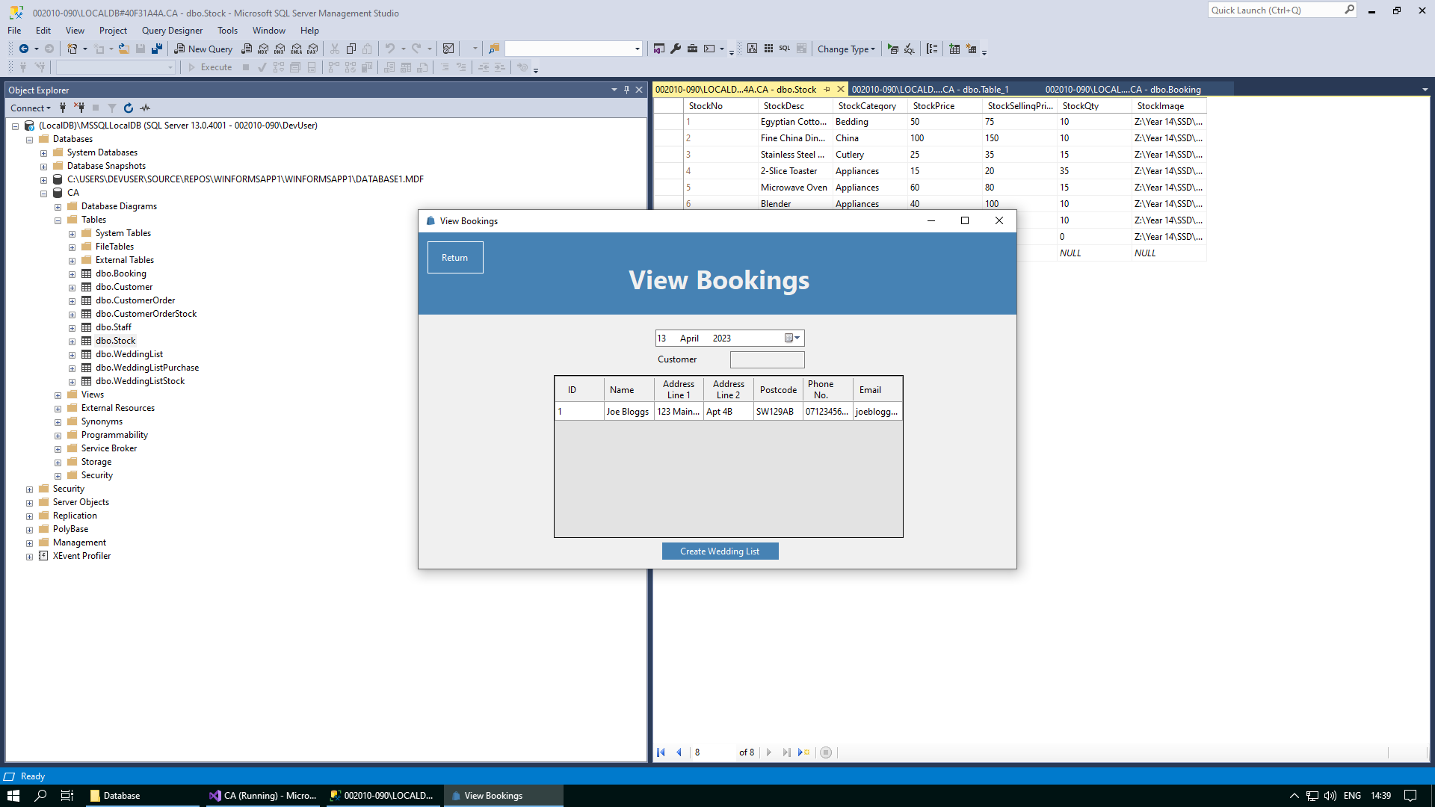

You can select the date you want to view the bookings for by clicking on the date time picker and selecting a date from the drop down. When you open the form, today’s date will be automatically assigned to the date selected in the date time picker. However, you can change this and select the date that you would like to view the bookings made for.

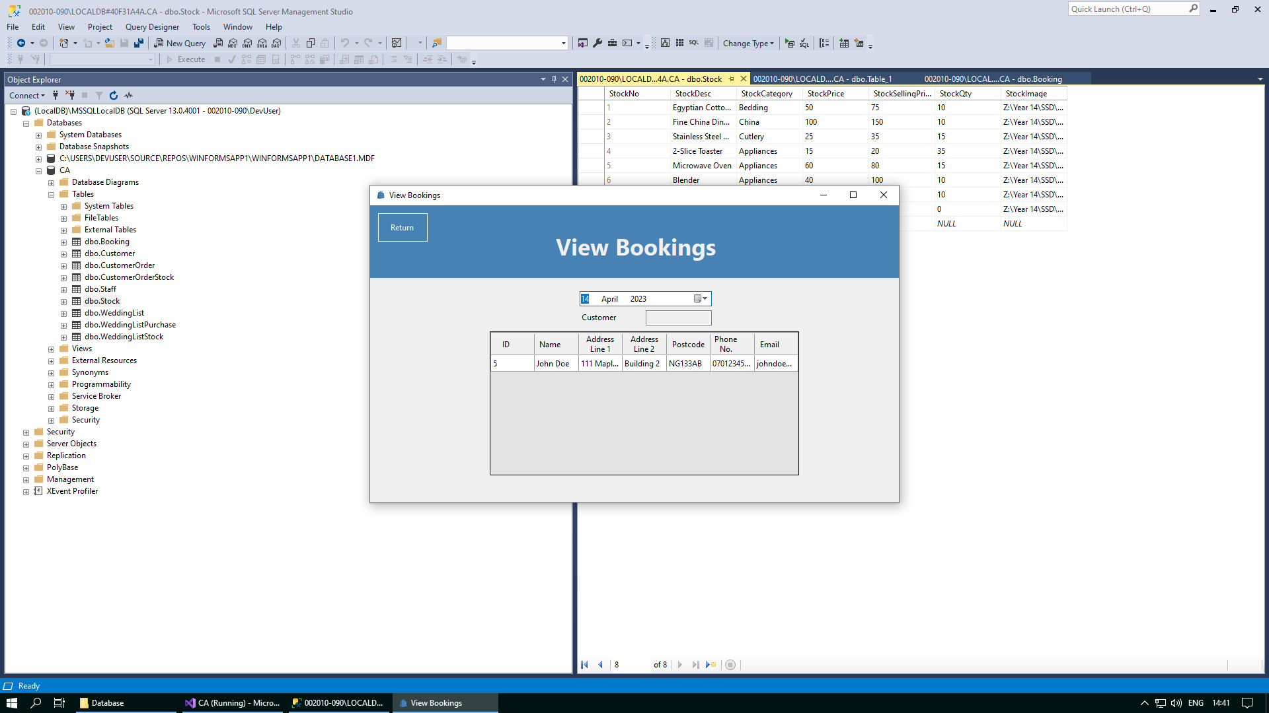

When you select a customer, you can make a wedding list for that customer by clicking the “Create Wedding List” button. This feature will only be available if the date selected in the date time picker is today. As well, this button will only say “Create Wedding List” if the customer selected has not already made a wedding list yet.

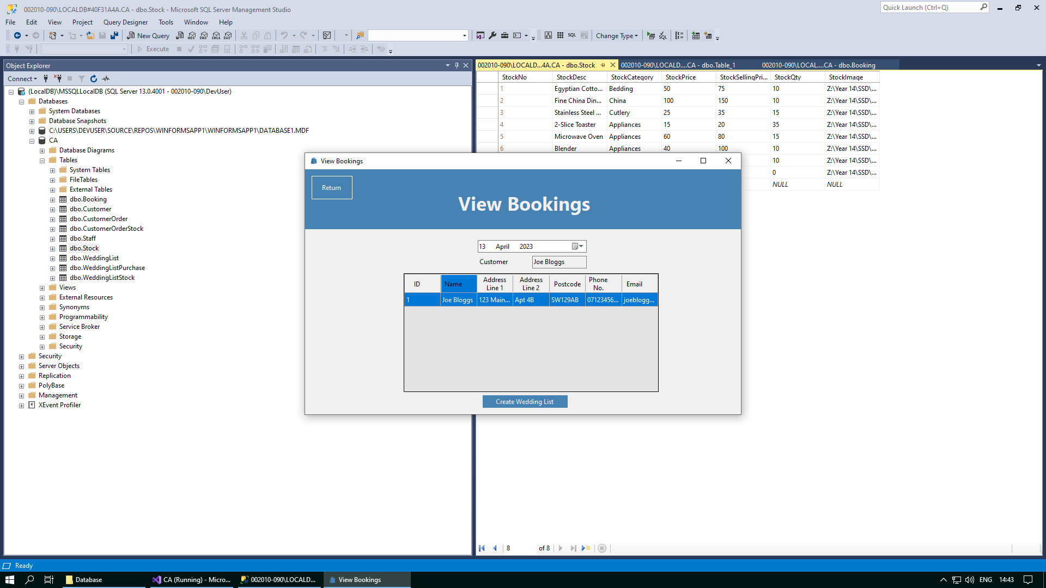

If you select a customer and then you click on the “Create Wedding List” button, the following message box will be displayed. You will not be automatically be brought to the Wedding List Stock form. If you want to now add stock to the wedding list for this customer, you will have to reselect this customer from the data grid view and click on this button again, which will now say “Update Wedding List” instead of “Create Wedding List”. It is important to note that when trying to create a new wedding list and go directly to the Wedding List Stock form in one click, the details for the new wedding list may not be passed over. Therefore, it is necessary to create the wedding list first and then select the customer again to add stock to the wedding list. For a more detailed explanation on this, please visit the Further Help/FAQ setion of this document.

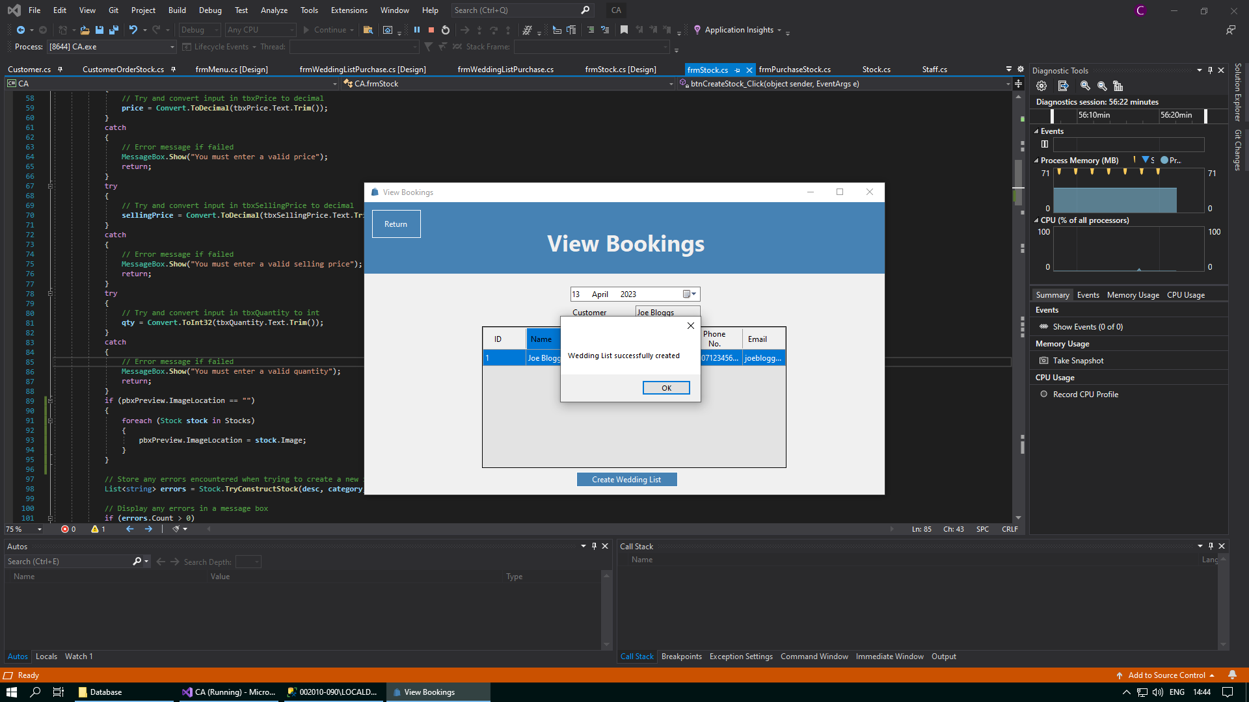

If there are customers who have made a booking for today and you have selected today in the date time picker, and then you try to click on the “Create Wedding List” button without selecting a customer, you will be met with the following error message:

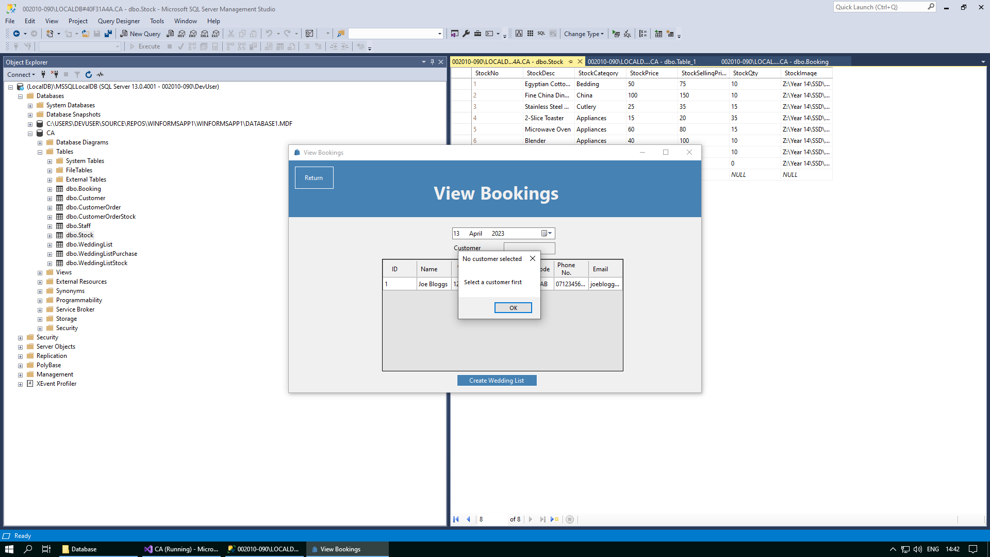

Here is an example of what this button will now look like after a wedding list has been made for a customer, and this customer is reselected from the data grid view. When you click on this button, you will be brought to the Wedding List Stock form, where you can now add stock to the wedding list for this customer.

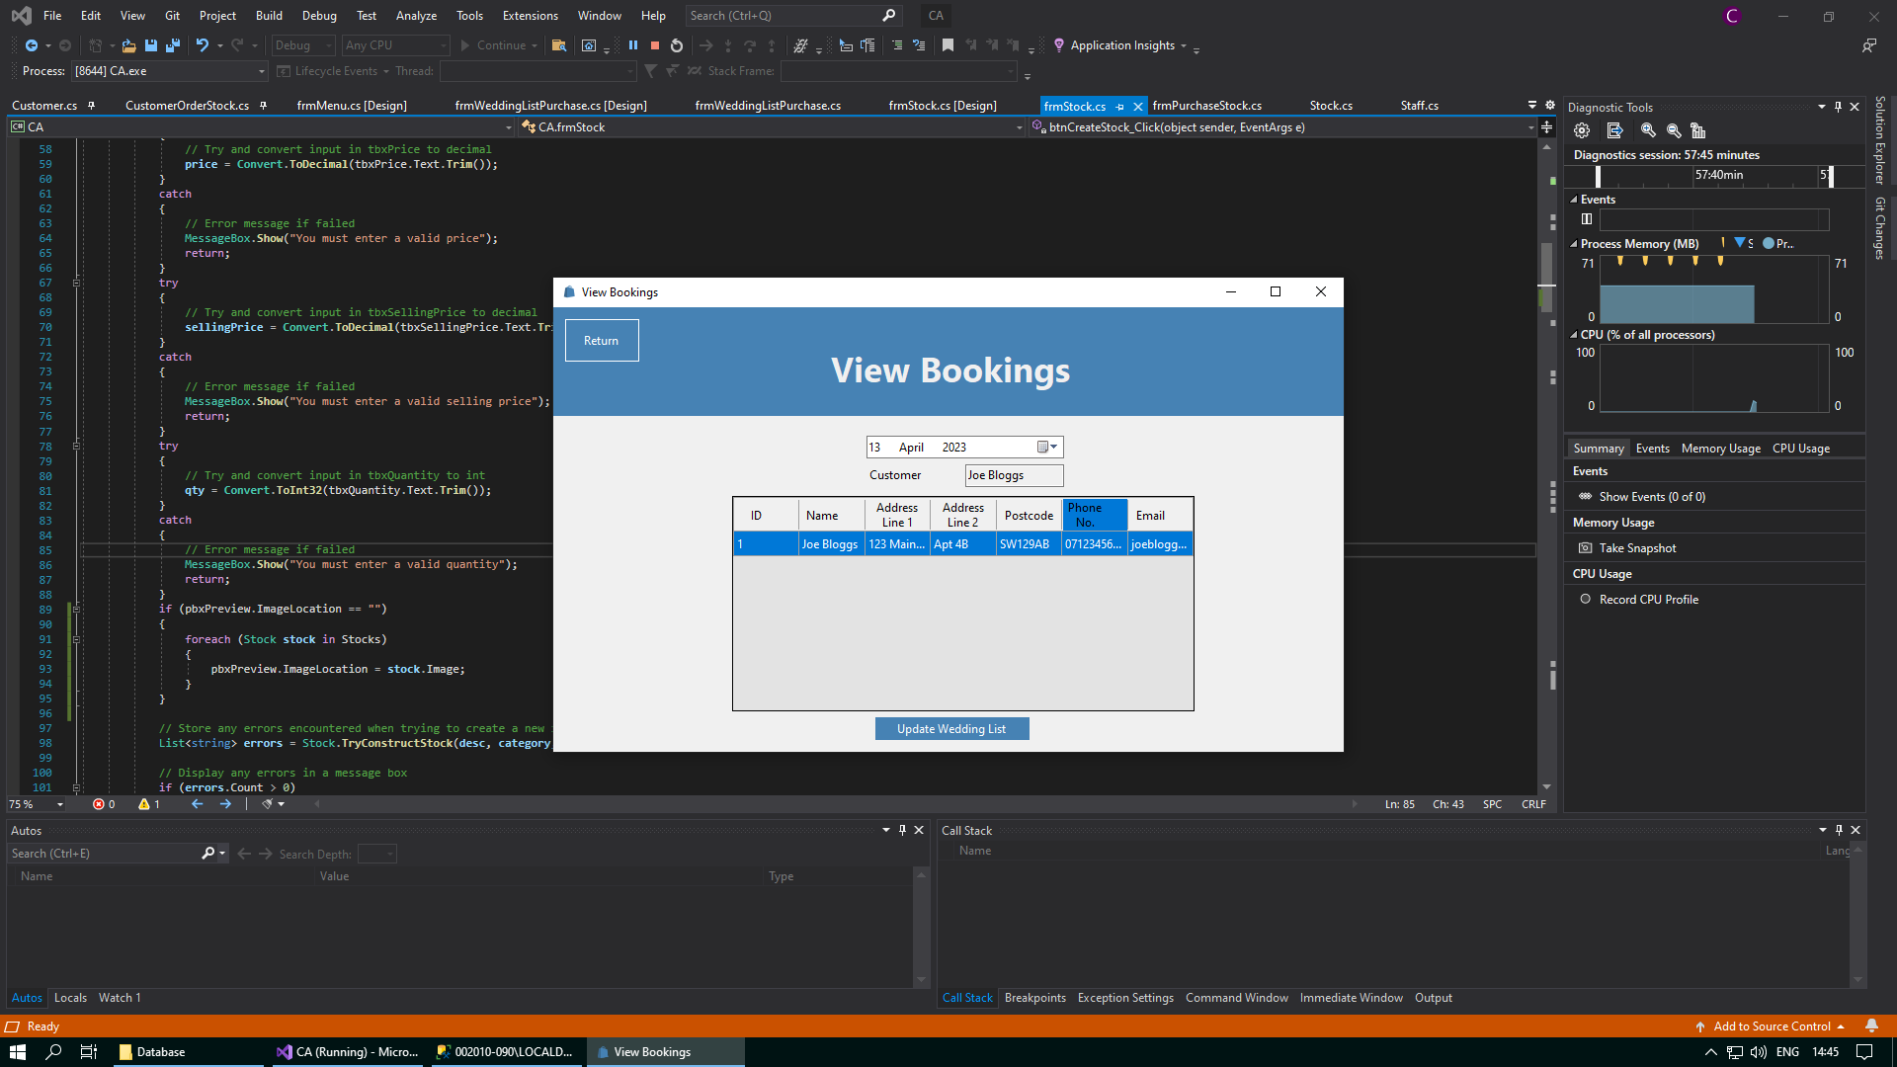

After items of stock have been added to a wedding list and the customer is happy with all the items on their wedding list, this wedding list must be marked as complete in order for other customers to be allowed to purchase stock from this wedding list. If you select a customer who has marked their wedding list as complete and you click the “Update Wedding List” button, you will be met with the following error message:

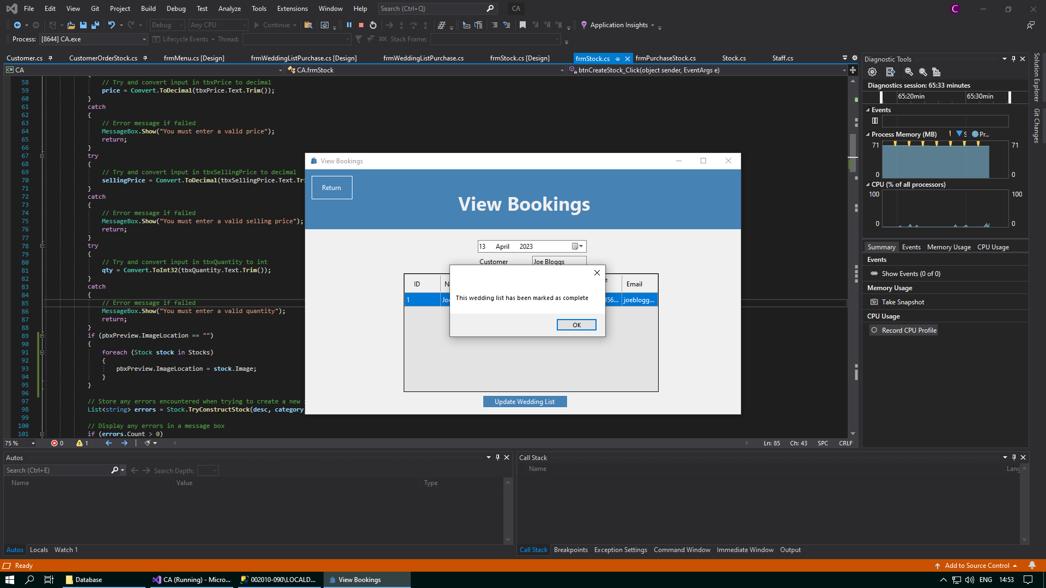

In addition, to help facilitate easier navigation between different forms, a “Return” button has been placed in the top left corner of the page to take you back to the Welcome form whenever you want. You can conveniently access the Welcome form again by clicking on the “Return” button situated in the top left corner of the screen.



## Wedding List Stock Form

Whenever you make a wedding list for a customer in the View Bookings form, you can now visit this form whenever you select this customer, so that you can add stock to the wedding list for this customer. In this form can select stock from the data grid view, choose the quantity that you would like to add to the wedding list, and then add it to your cart to add to the wedding list for this customer. You can add as many items as you like to the cart.

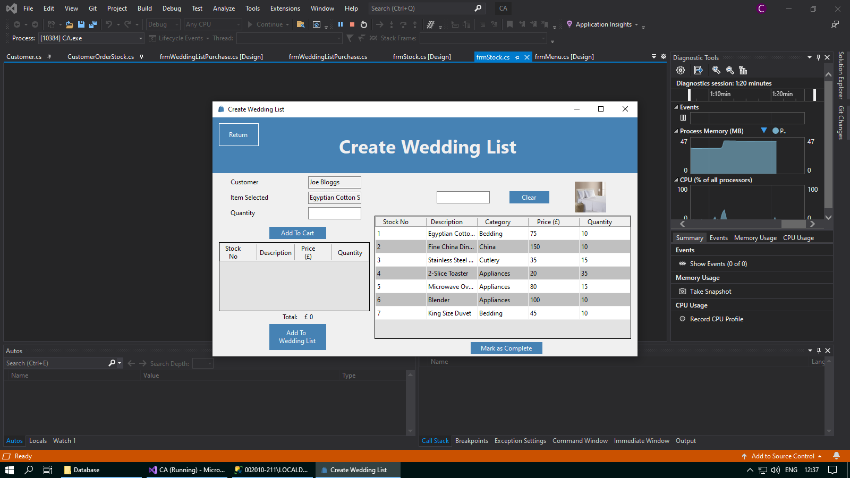

If you accidentally click the “Add To Wedding List” button without adding any stock to the cart to be added to the wedding list, you will get the following error message:

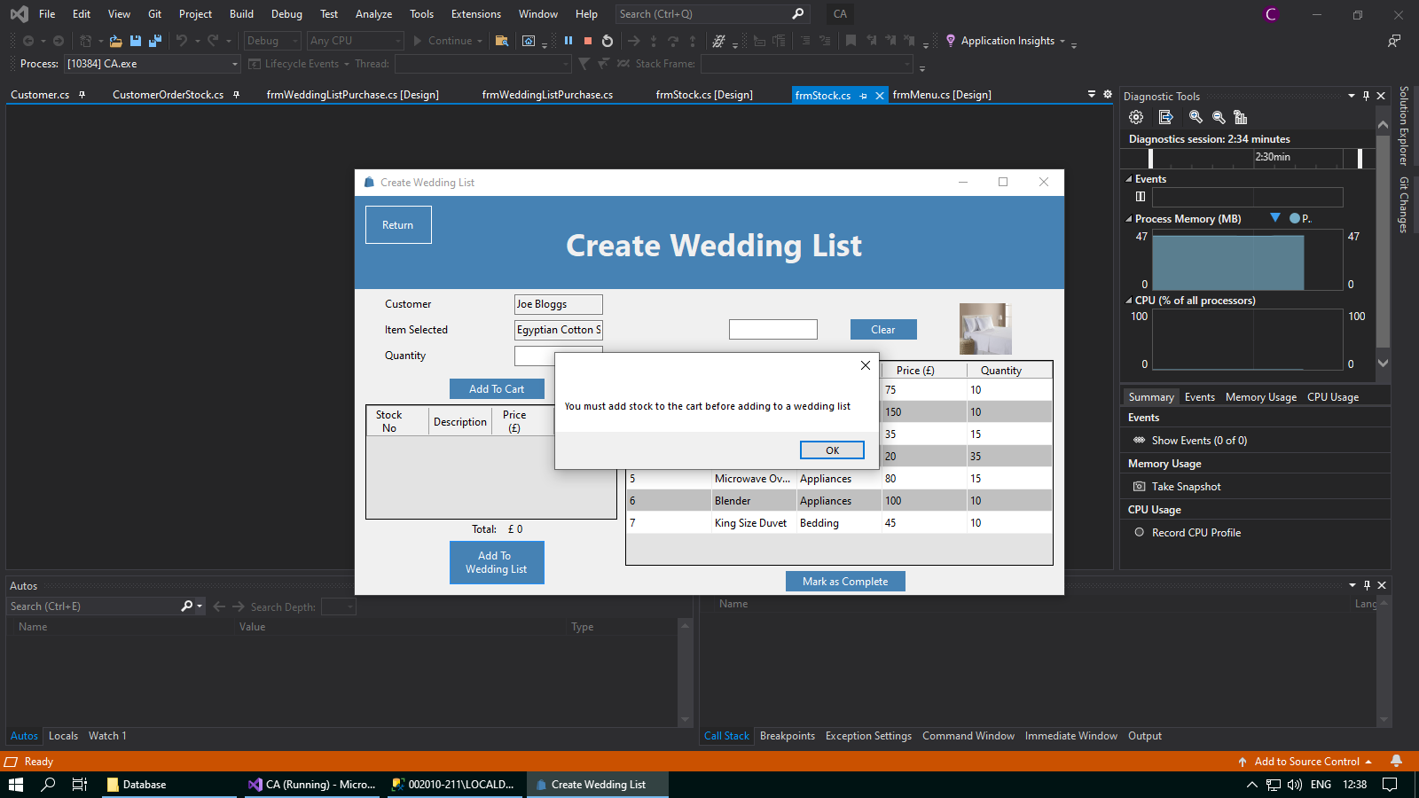

As well as this, if you select an item of stock and do not choose a quantity to add to the cart, and then you click the “Add To Cart” button, you will also get the following error message:

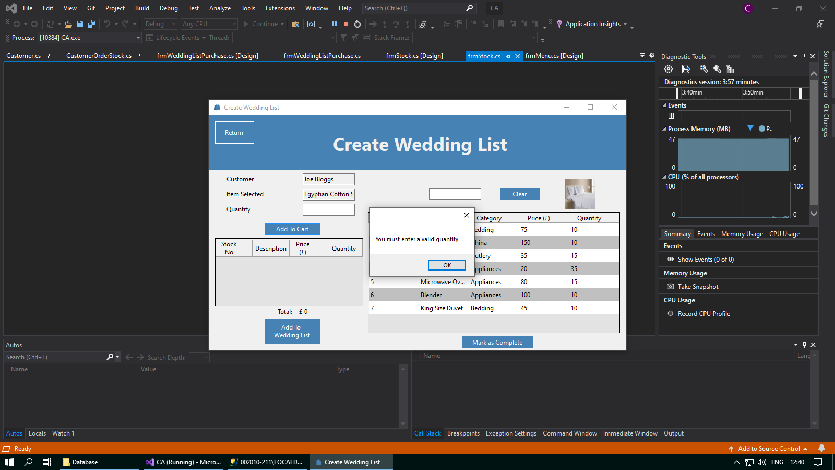

When you enter a chosen quantity into the text box, you can then add the selected stock to the cart by clicking the “Add To Cart” button. The item(s) of stock will be successfully added to the cart, and you can then either select new items to add to the cart, or you can choose to add these items to the wedding list for the customer.

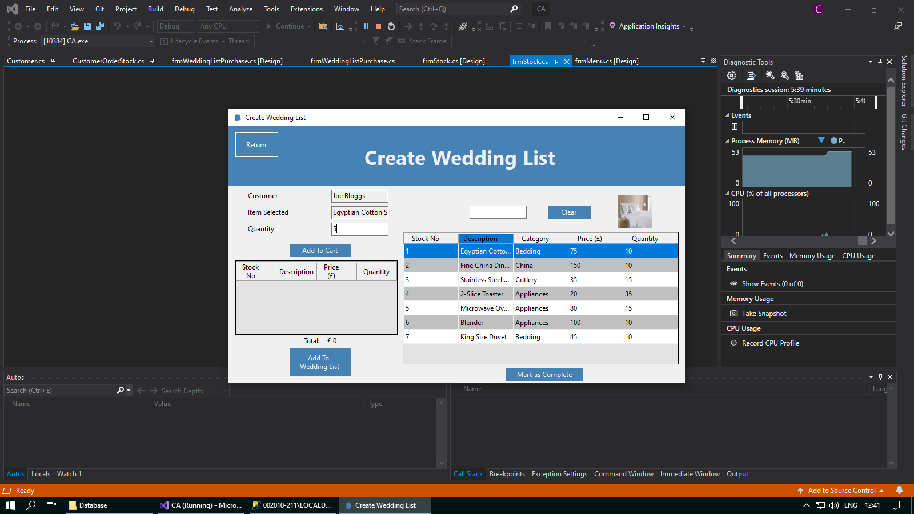

Whenever you have added all the stock to the cart that you would like to add to the wedding list for the selected customer, you can then confirm this by clicking on the “Add To Wedding List” button that sits below the cart.

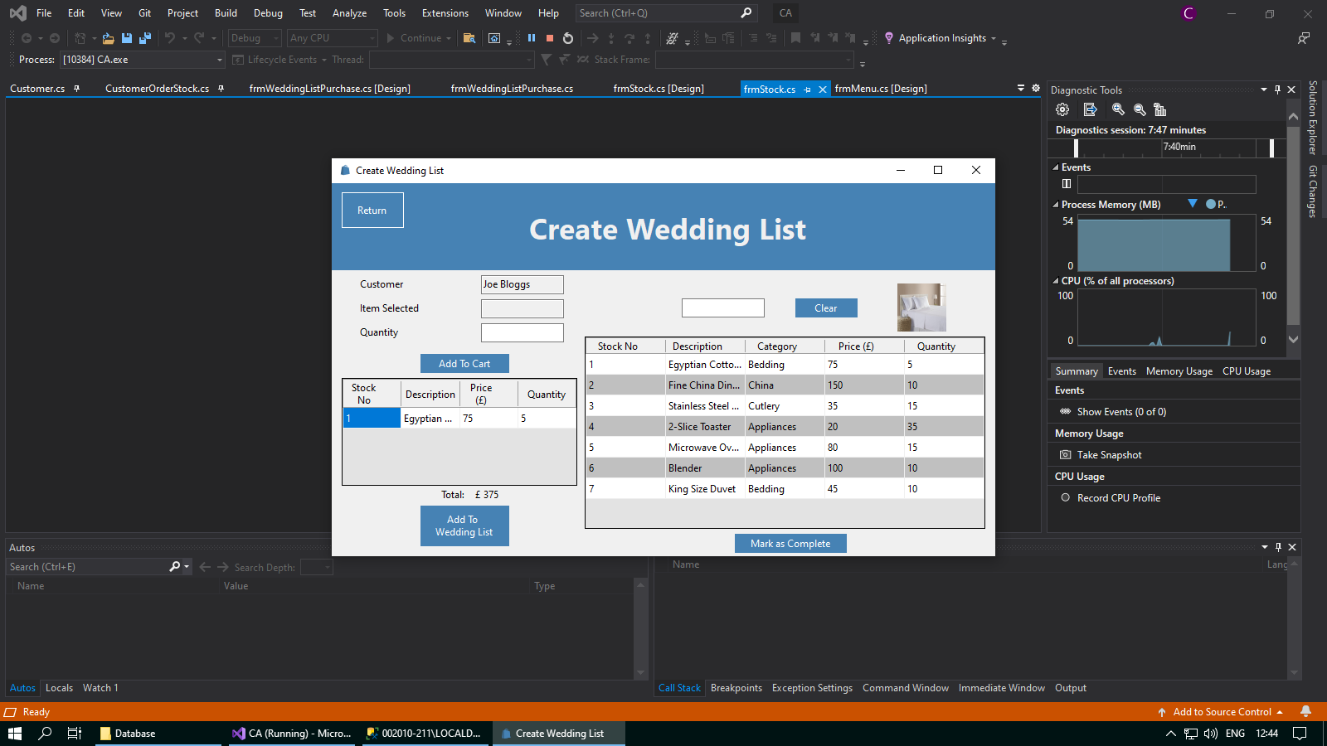

Whenever you have completed adding stock to the wedding list for the selected customer, you can then exit the form using the “Return” button. This will take you back to the View Bookings form, where you can choose to create a wedding list for other customers. If you have forgotten to add any items of stock to the wedding for the customer, you can reselect them from the data grid view in the View Bookings form, and select the “Update Wedding List” button again to return to this form. You can only do this if the wedding list has not been marked as complete.

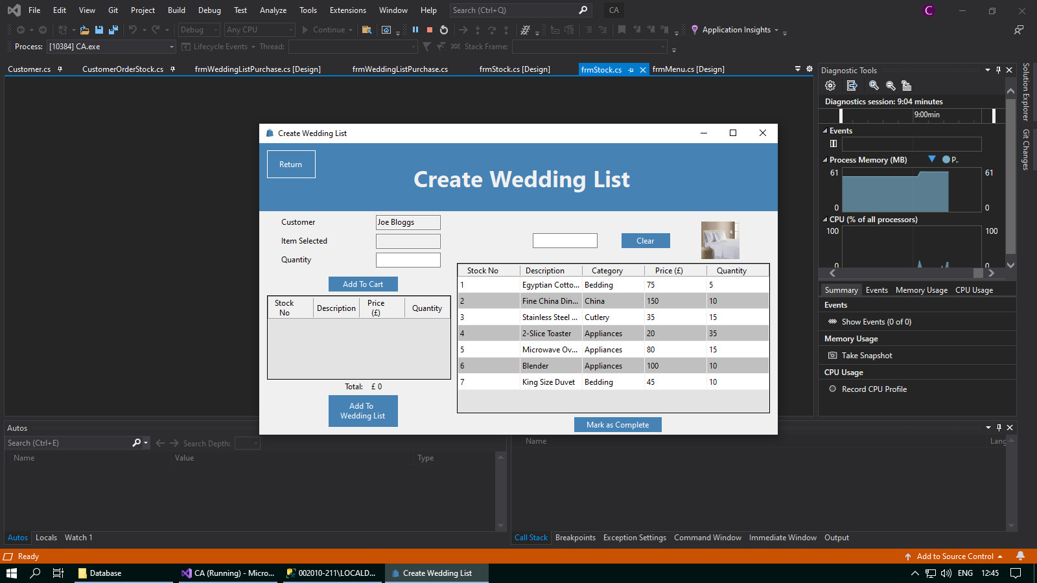

If there are many items of stock in the database and you do not want to have to search through all the stock in the data grid view, then you can use the text box above the data grid view to search for the stock you need. This text box will save any input you enter as a search string, and this will be used to return any items of stock from the Stock table in the database with any details similar to the input you enetered.

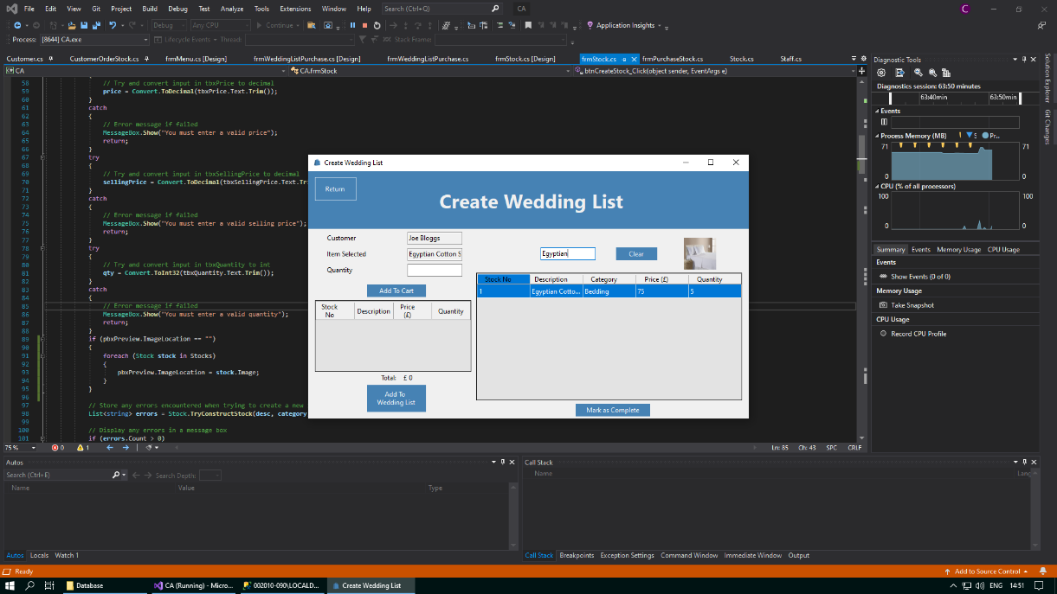

When you have finished searching for the items of stock that you need, you can then clear your search using the “Clear” button. This will wipe any text you have may entered into the textbox and will show all stock from the Stock table in the data grid view again.

When you have finished adding items of stock to the customer’s wedding list, you can mark this customer’s wedding list as complete by clicking on the “Mark as Complete” button. This is important as it means that the wedding list will now be displayed in the Wedding List Purchase form, where customers can purchase stock from this wedding list.

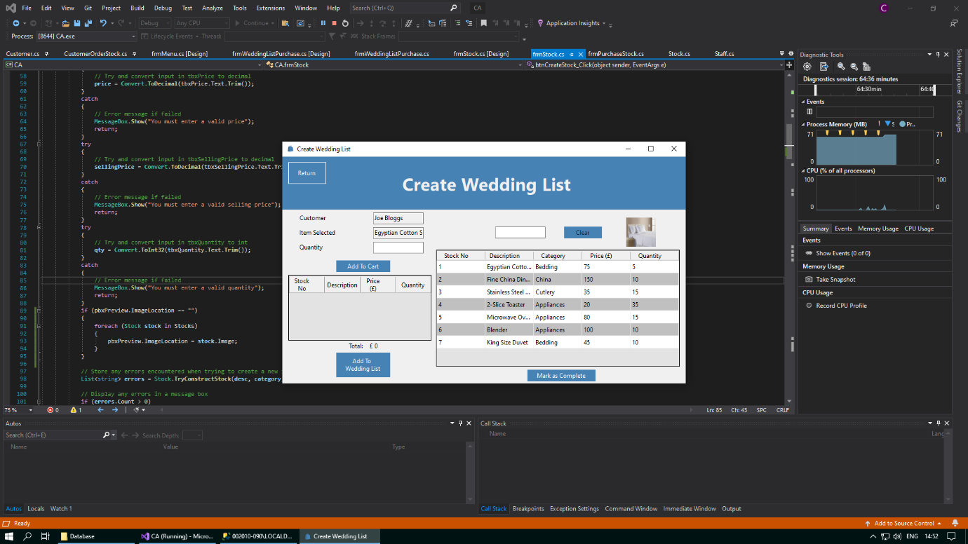

You will be greeted with this message, and then you will be returned to the View Bookings form. You can no longer add any stock to the wedding list for this customer. This customer’s wedding list will now be available to purchase from in the Wedding List Purchase form.

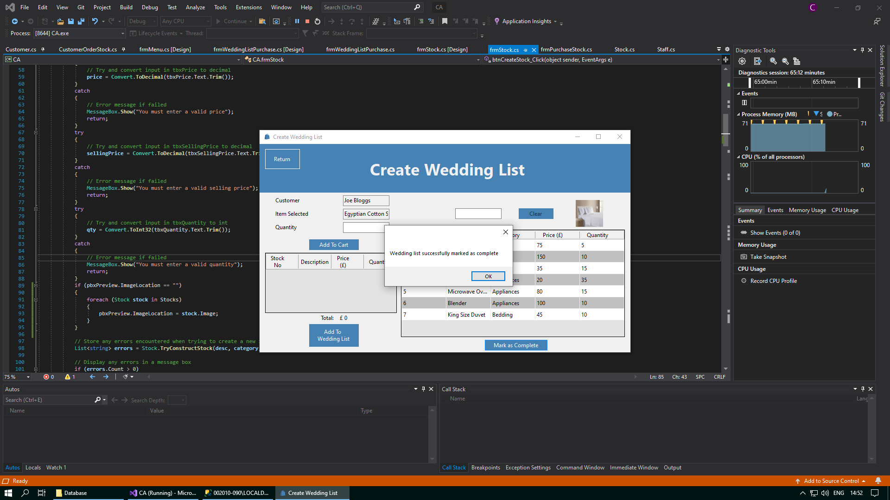

## Wedding List Purchase Form

This form serves as a central hub to facilitate in the purchase of stock from wedding lists. When this form is opened, you will be prompted to select a customer to buy for and a customer to buy as. The customer to buy as is the customer that will be making a purchase from a wedding list, and the customer to buy for will be the customer with a wedding list that the customer to buy as will be purchasing from.

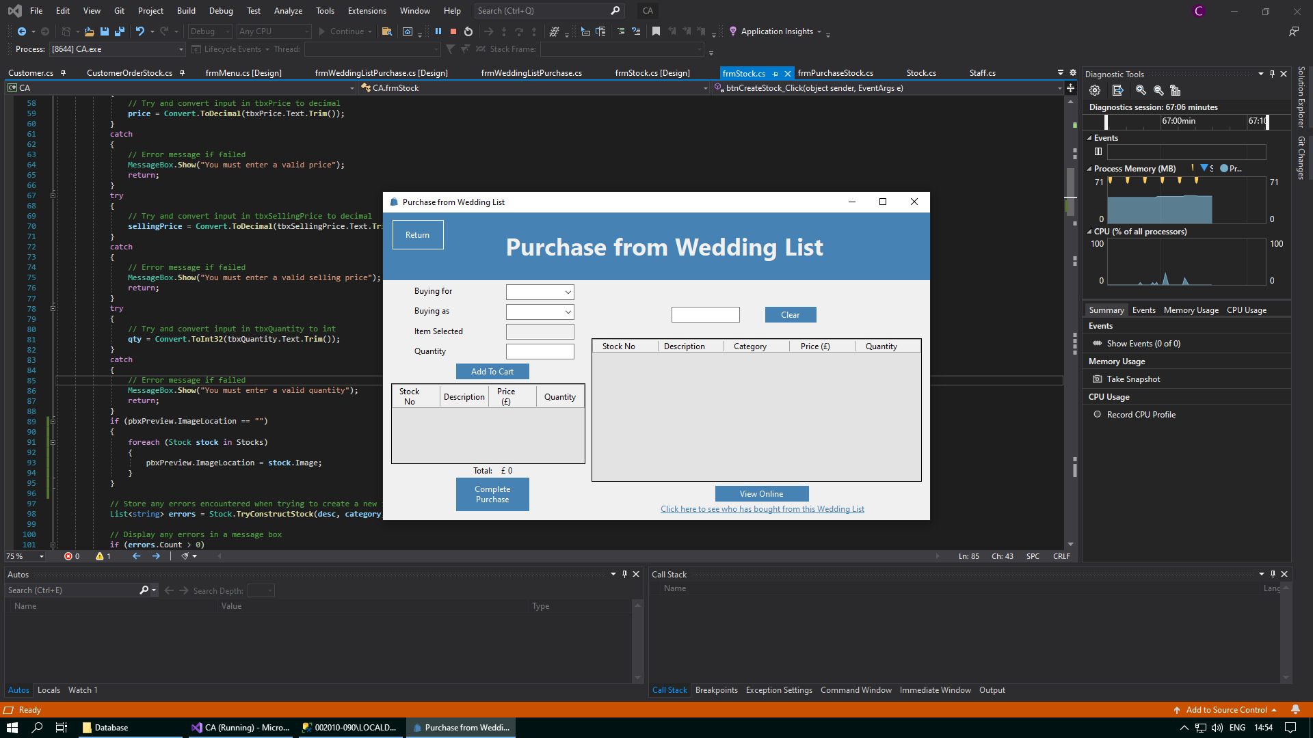

Whenever you select a customer in the buying for combo box, you will be able to click the “View Online” button to view their wedding list online in a website. However, if the “View Online” button is clicked and no customer to buy for has been selected, then the following error message will show:

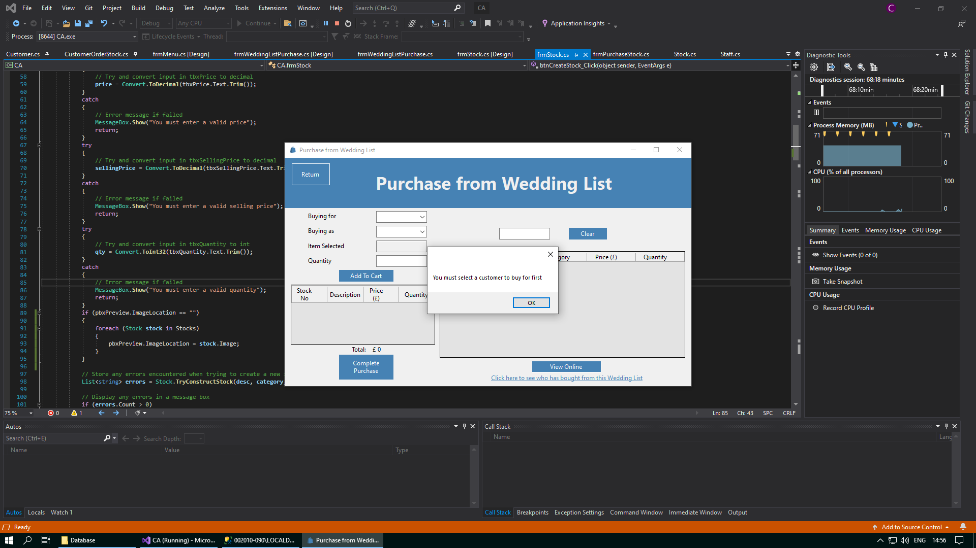

You can also view the customers that have bought from the currently selected wedding list. However, if the “Wedding List Customers” label has been clicked and no customer to buy for has been selected, then the following error message will show:

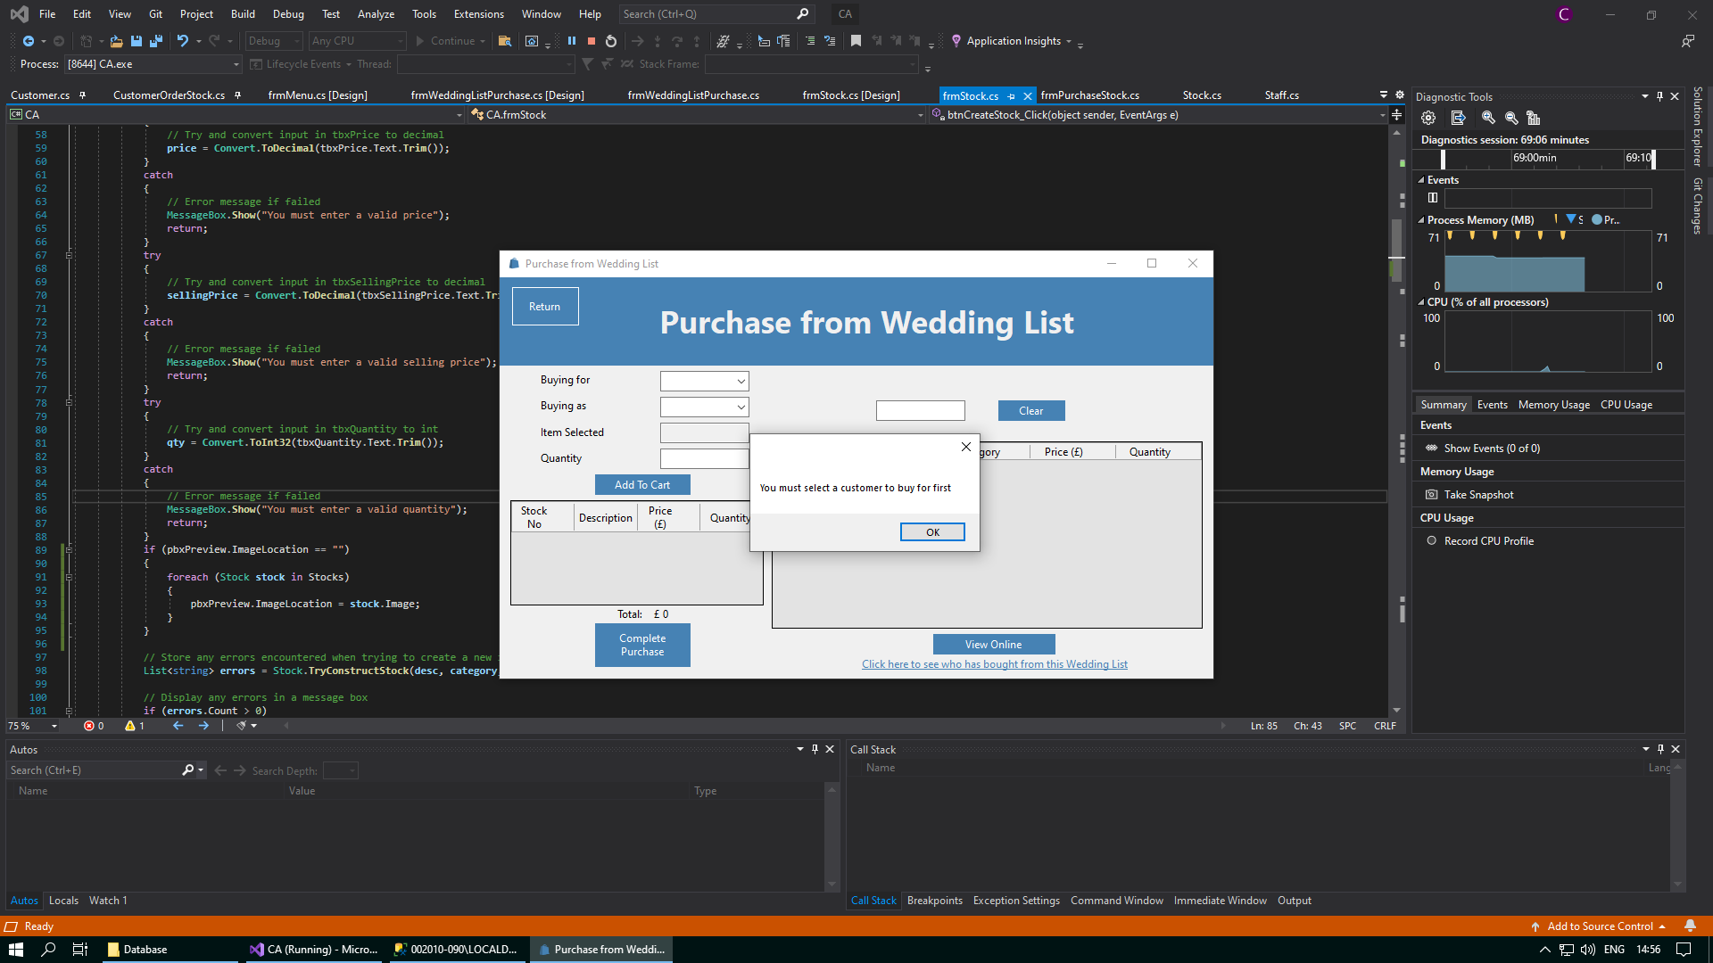

If you accidentally click the “Complete Purchase” button without selecting a customer to buy for/buy as and you have also not added any stock to the cart to purchase, then the following error message is displayed:

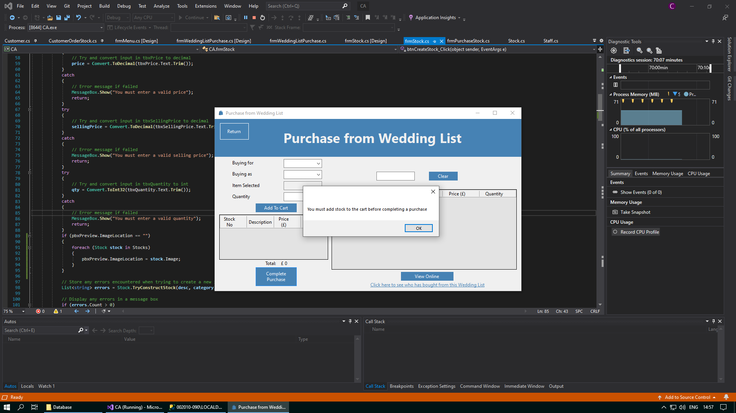

When you open the Wedding List Purchase form, no customer to buy for will be selected as default. When you choose a customer to buy for from the drop down, you can see all the items in their wedding list only.

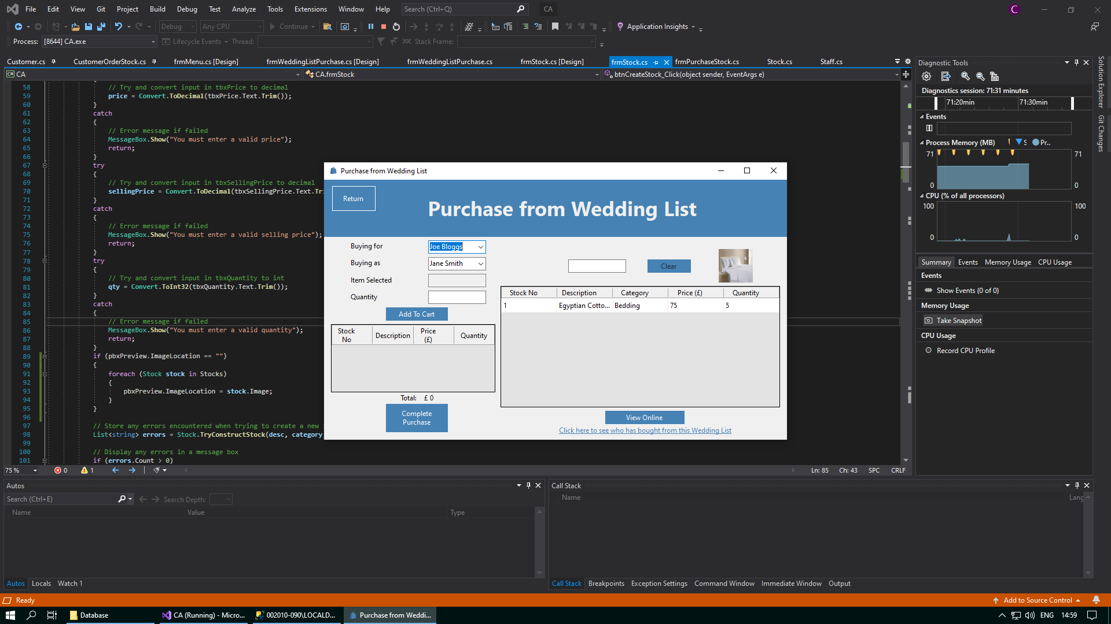

When you have a selected a customer to buy for, you can now click the “View Online” button, which will open the currently selected wedding list in a website online. You may be prompted to select your preferred browser. This website is only run on your machine locally.

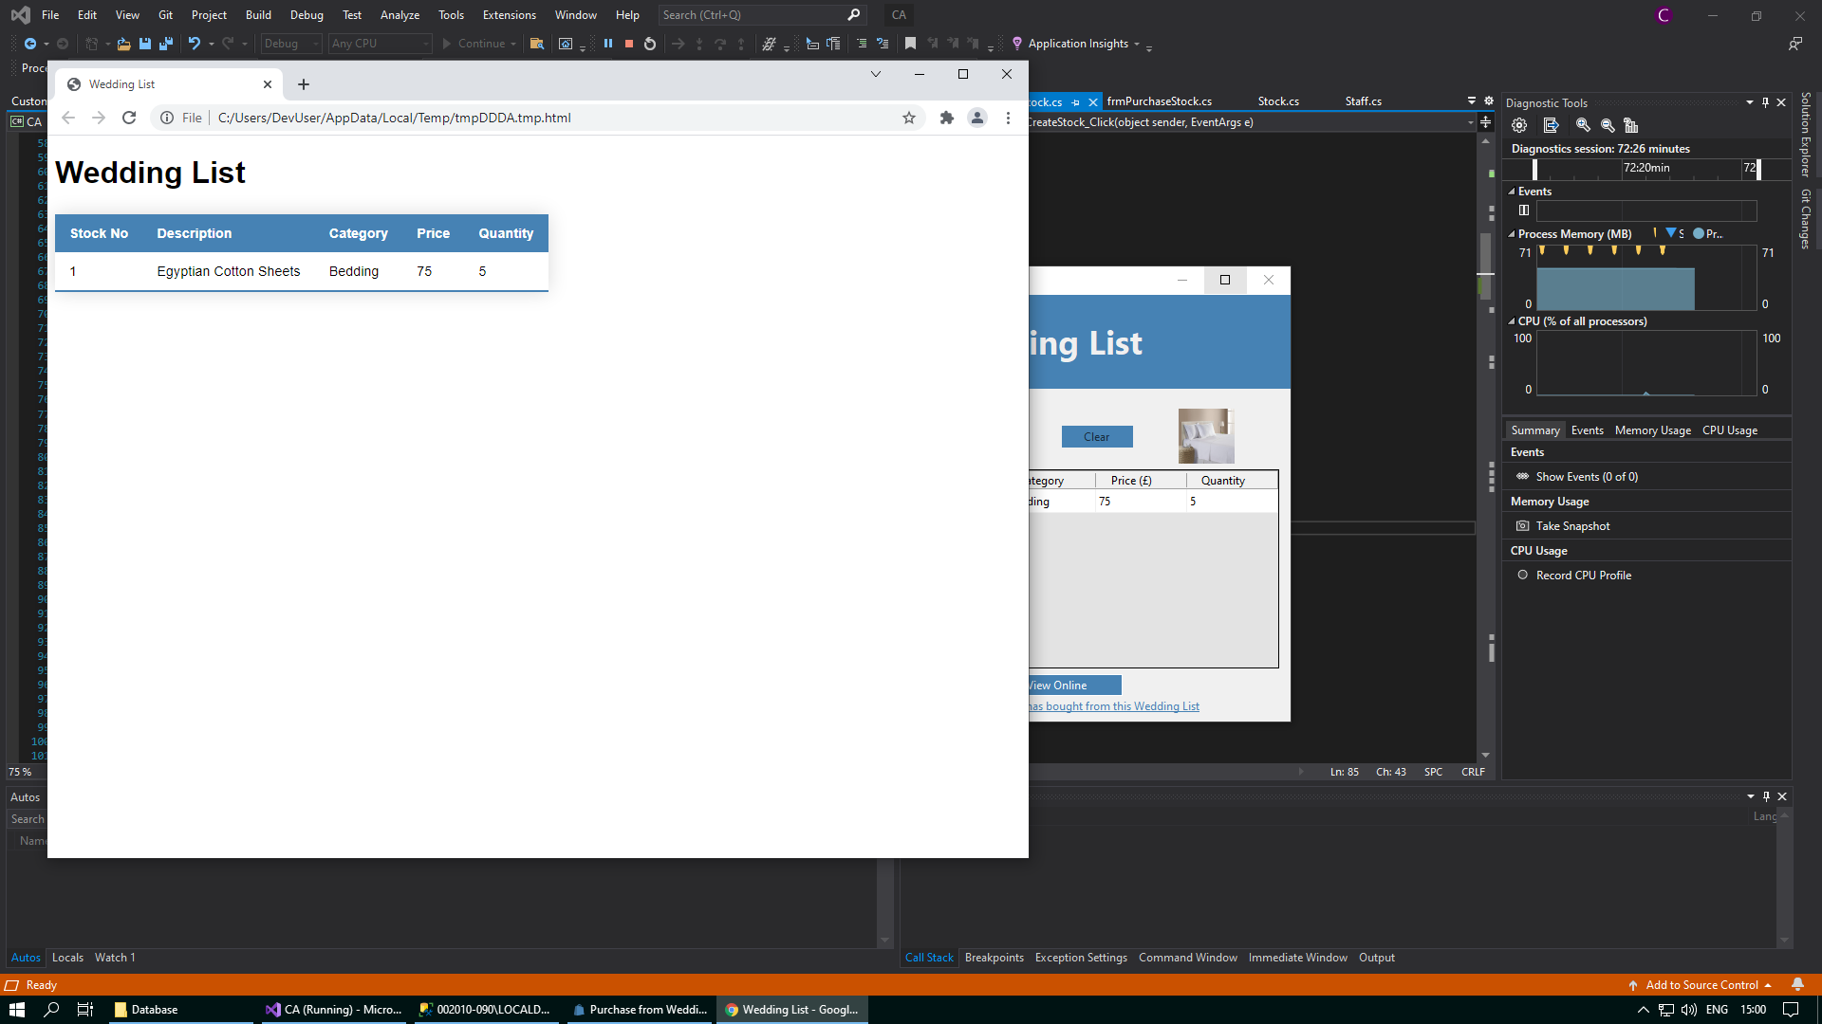

When you have selected a wedding list to buy from, you can also see which customers have bought from the wedding list. This will open the pop up form Wedding List Customers, which will be detailed more in the Wedding List Customers Form section of this document.



When you open the form, no customer to buy for or a customer to buy as will be selected as default. However, when you select a customer to buy for, a customer to buy as will be automatically selected. This may not be the customer that you want to buy as, so you can change this using the drop down combo box.

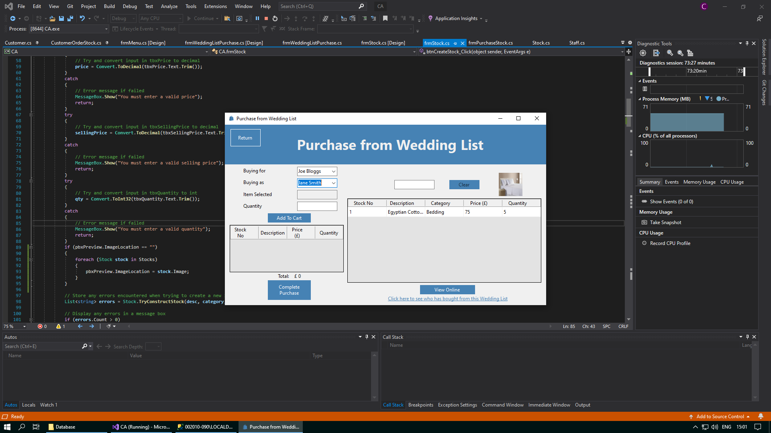

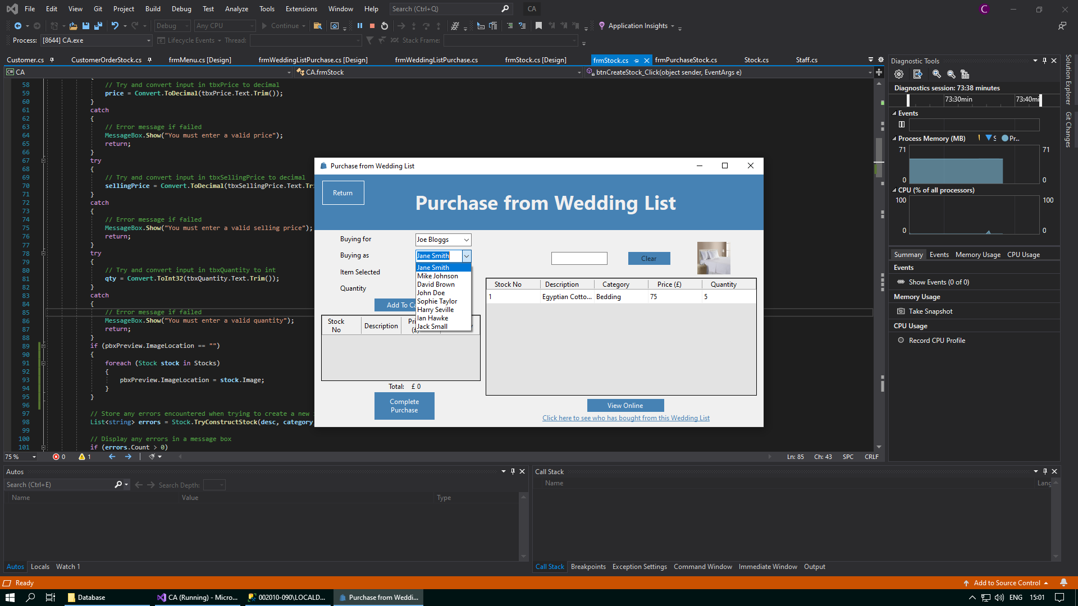

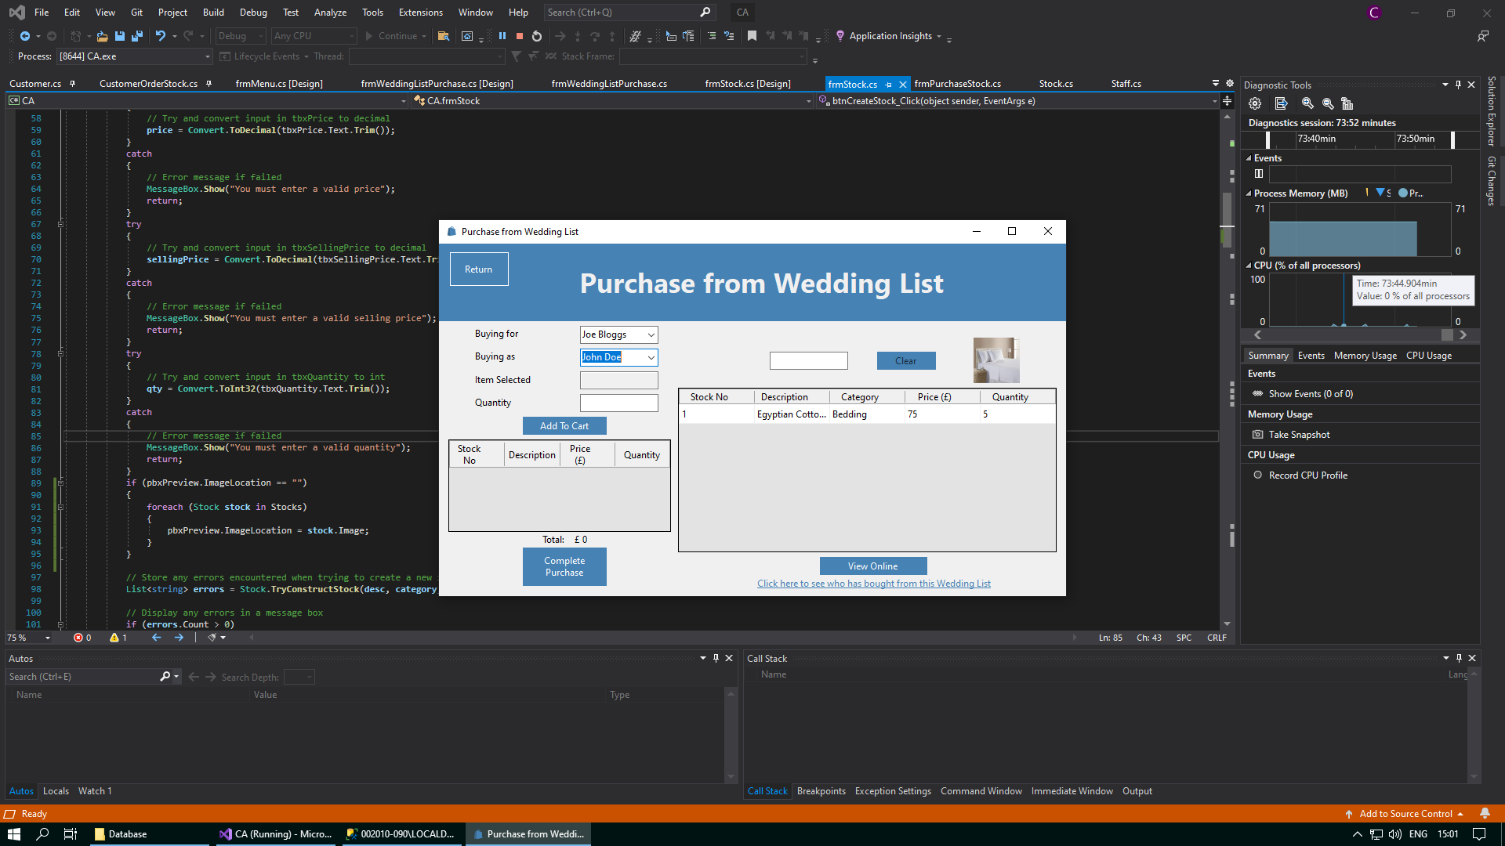

Note - you cannot select the same customer who is currently being bought for as the customer who is buying as.

After you have selected a customer to buy for and a customer to buy as, you can purchase stock from the chosen wedding list. In this form can select stock from the data grid view, choose the quantity that you would like to buy, and then add it to your cart for purchase from this wedding list. You can add as many items as you like to the cart.

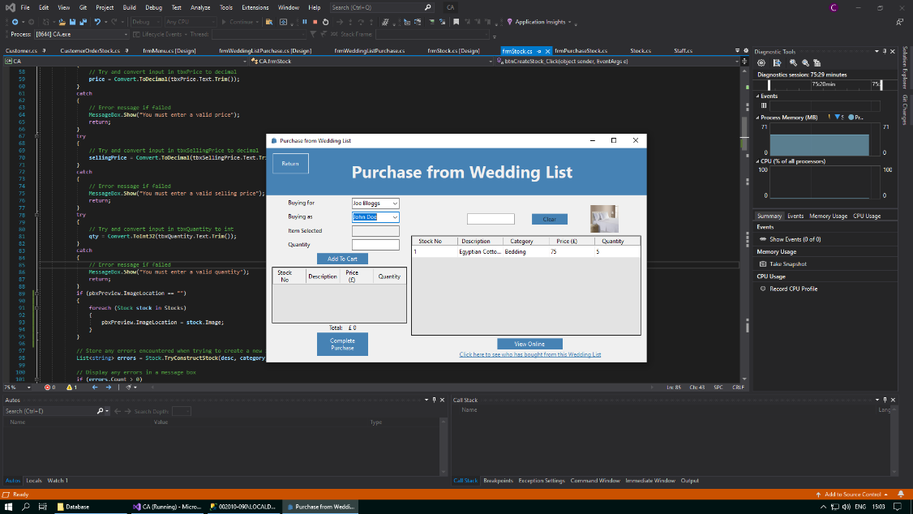

If you accidentally click the “Complete Purchase” button without adding any stock to the cart for purchase, you will get the following error message:

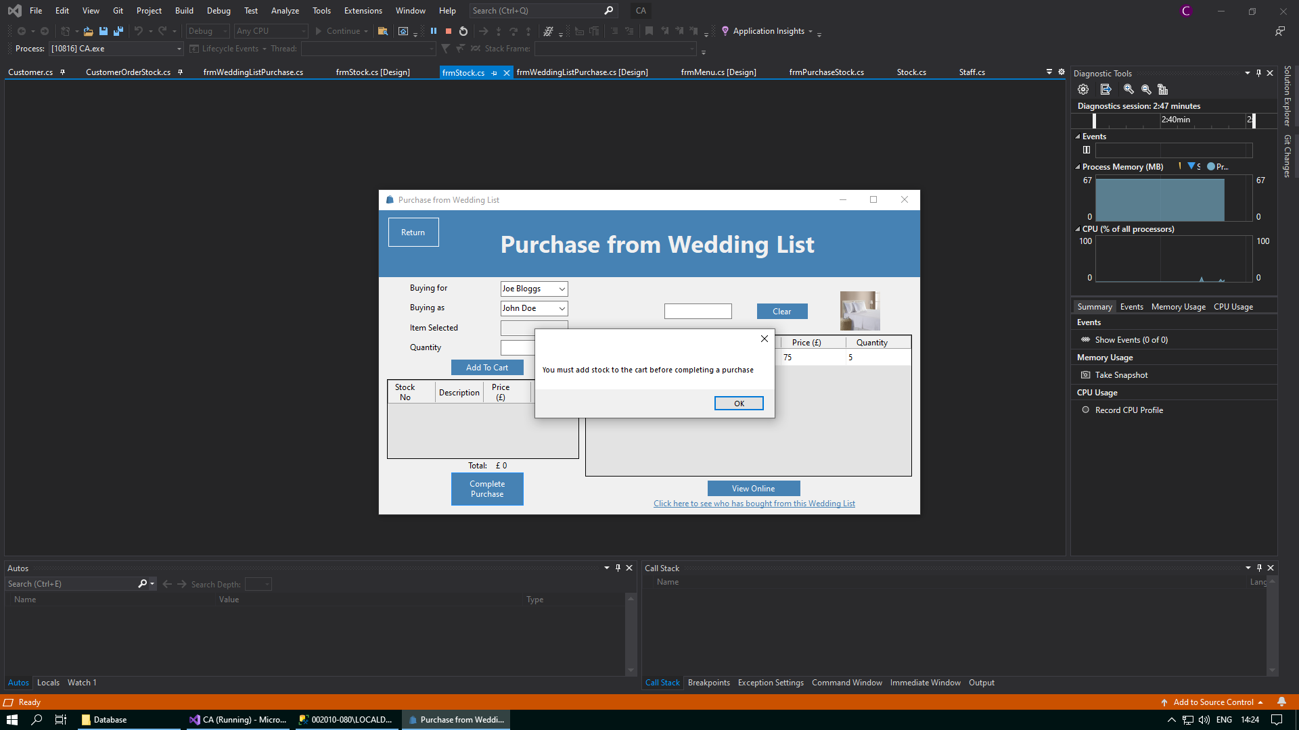

As well as this, if you select an item of stock and do not choose a quantity to add to the cart, and then you click the “Add To Cart” button, you will also get the following error message:

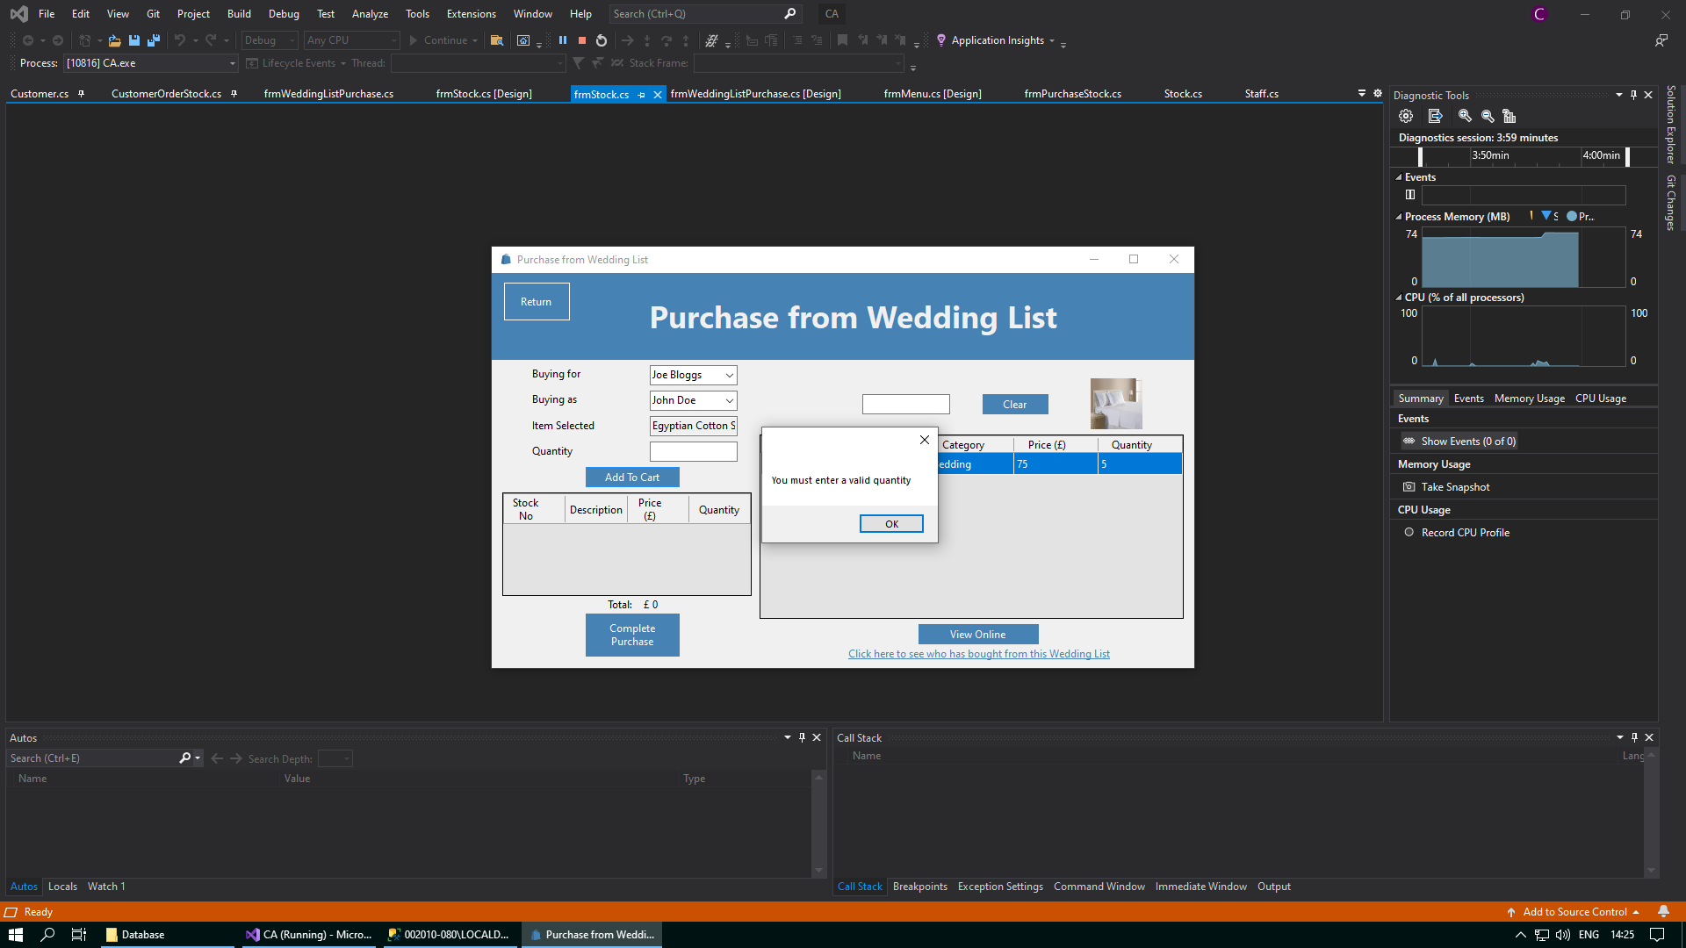

When you enter a chosen quantity into the text box, you can then add the selected stock to the cart by clicking the “Add To Cart” button. The item(s) of stock will be successfully added to the cart, and you can then either select new items to add to the cart, or you can choose to complete the purchase.

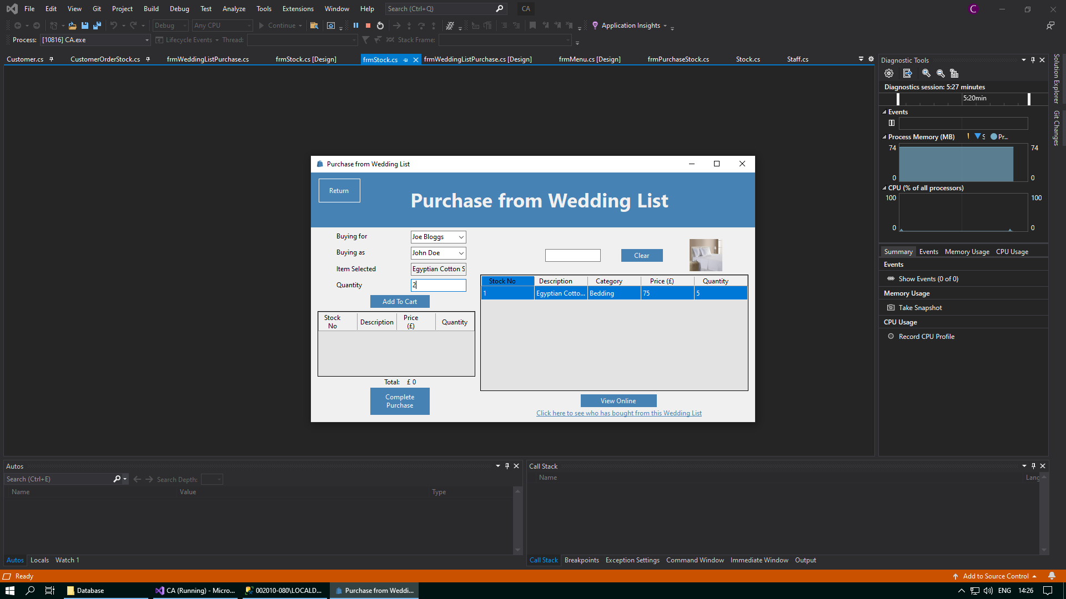

Whenever you have added all the stock to the cart that you would like to purchase from the selected wedding list, you can then confirm this purchase by clicking on the “Complete Purchase” button that sits below the cart.

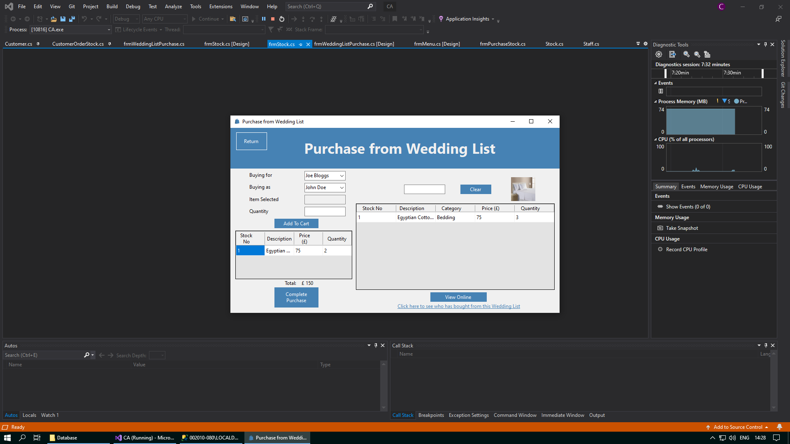

If the purchase is completed successfully, you will be presented with the following success message:

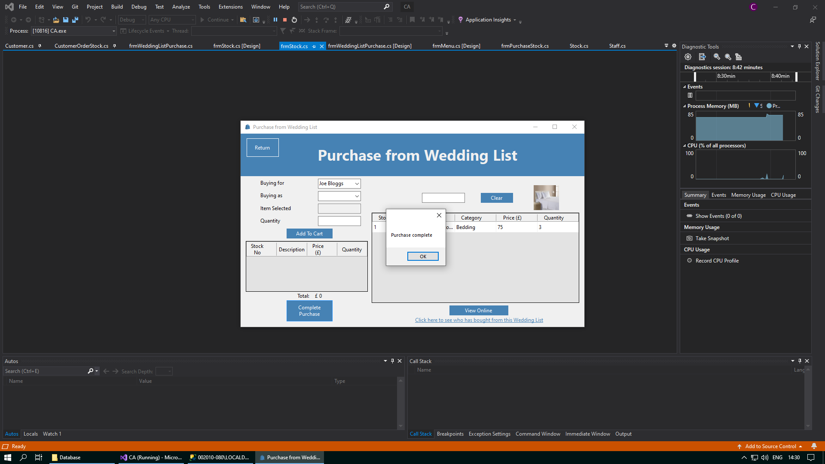

After you close the message box by clicking the “OK” button, the Wedding List Purchase form will refresh, and you will be presented with the form in the same state as it was when you first opened it.



In addition, to help facilitate easier navigation between different forms, a “Return” button has been placed in the top left corner of the page to take you back to the Welcome form whenever you want. You can conveniently access the Welcome form again by clicking on the “Return” button situated in the top left corner of the screen.



If there are many items of stock in the wedding list and you do not want to have to search through all the stock in the data grid view, then you can use the text box above the data grid view to search for the stock you need. This text box will save any input you enter as a search string, and this will be used to return any items of stock from the WeddingListStock table in the database with any details similar to the input you enetered. Only stock that is in the currently selected wedding list can be returned as search results.

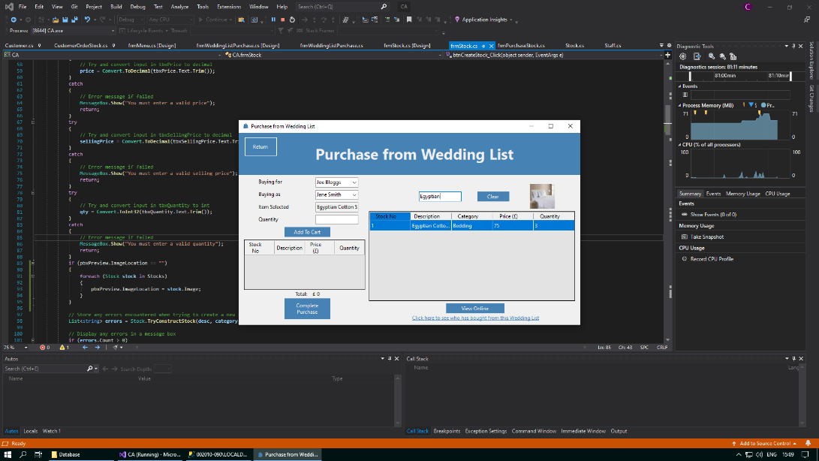

When you have finished searching for the items of stock that you need, you can then clear your search using the “Clear” button. This will wipe any text you have may entered into the textbox and will show all stock from the currently selected wedding list in the data grid view again.

If you purchase all the stock from a wedding list, this wedding list will be no longer available in the drop down

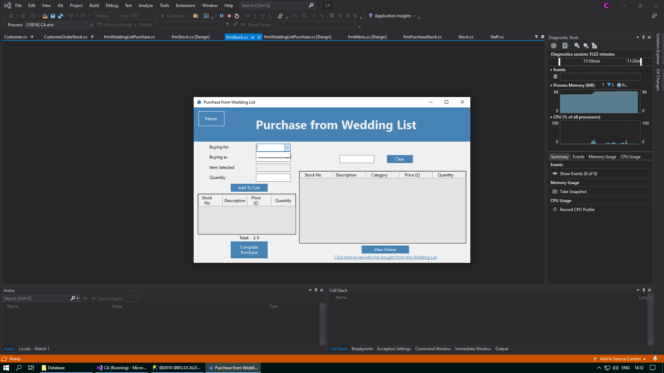

## Wedding List Customers Form

The Wedding List Customers form is a pop up form that will open over the Wedding List Purchase form. This form will open when you select a customer to buy for, and then you click the hyperlink “Click here to see who has bought from this Wedding List”. If no customers have bought from the wedding list, you will see the message “No customers have bought from this wedding list yet” when you click on the hyperlink “Click here to see who has bought from this Wedding List”.

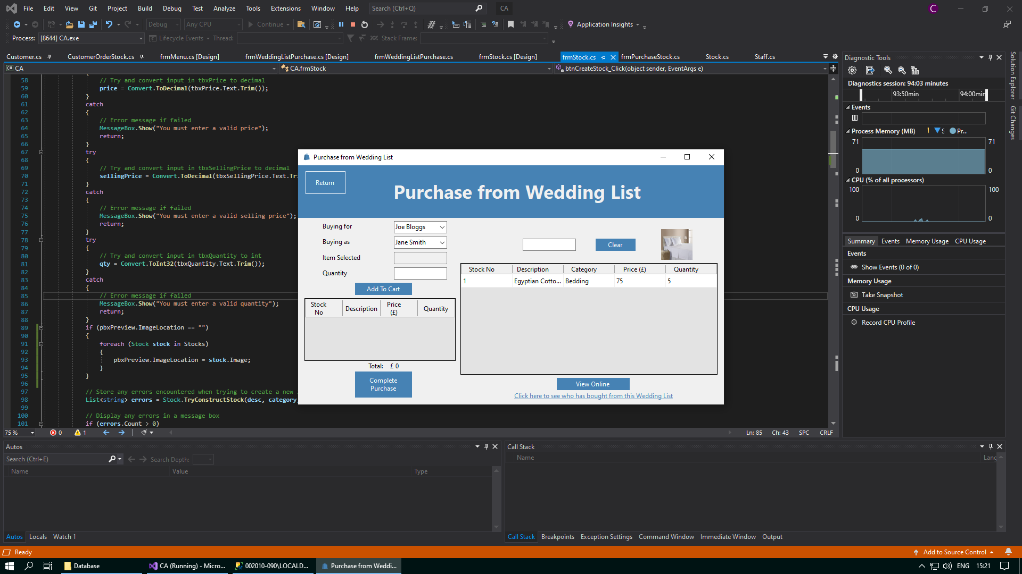

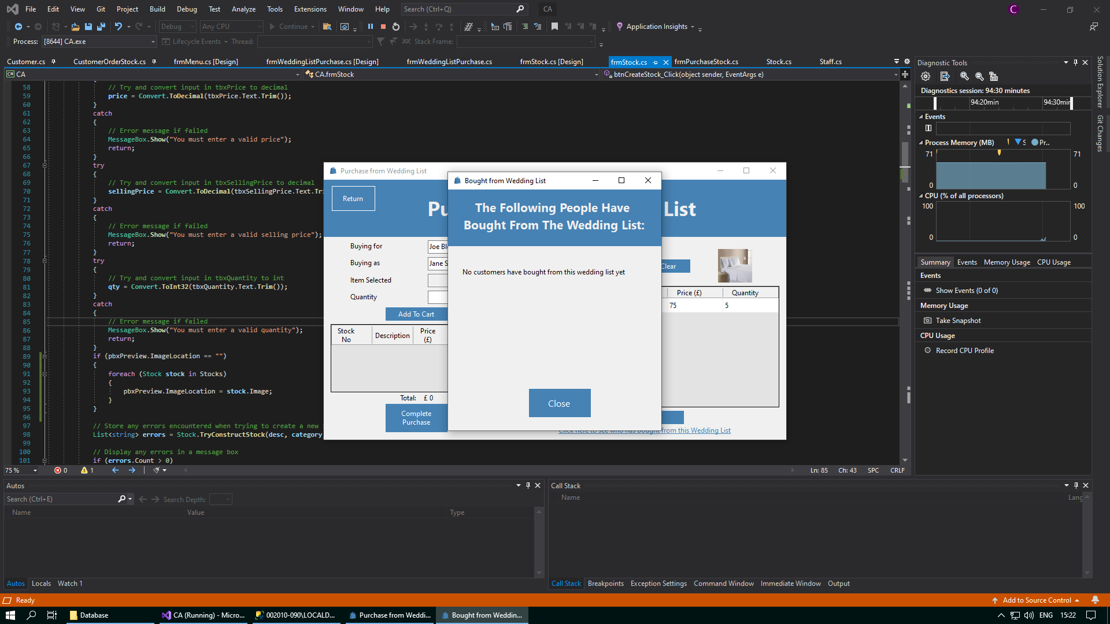

You can close this pop-up form by clicking the “Close” button.

If there are customers that have bought from the currently selected wedding list, you will see the names of these customers that have made a purchase when you click on the hyperlink “Click here to see who has bought from this Wedding List”.

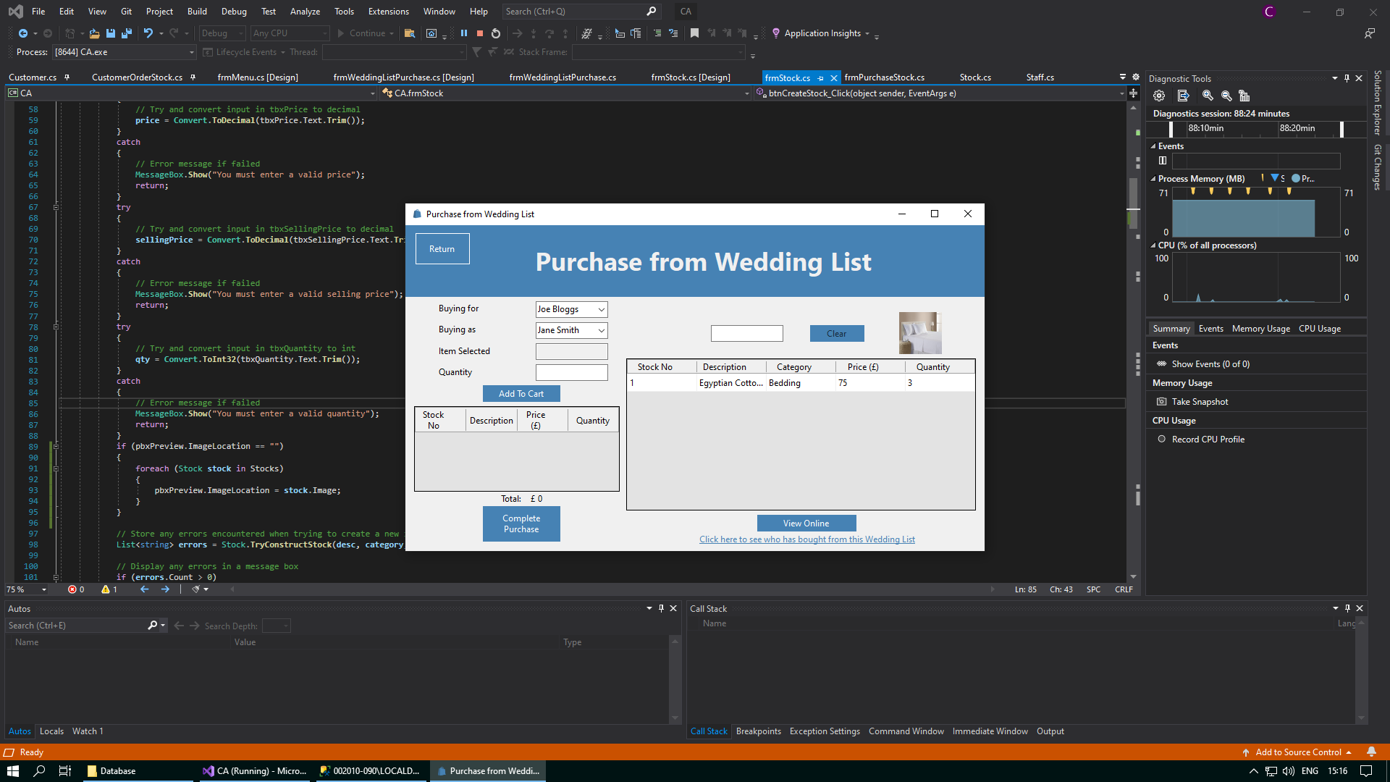

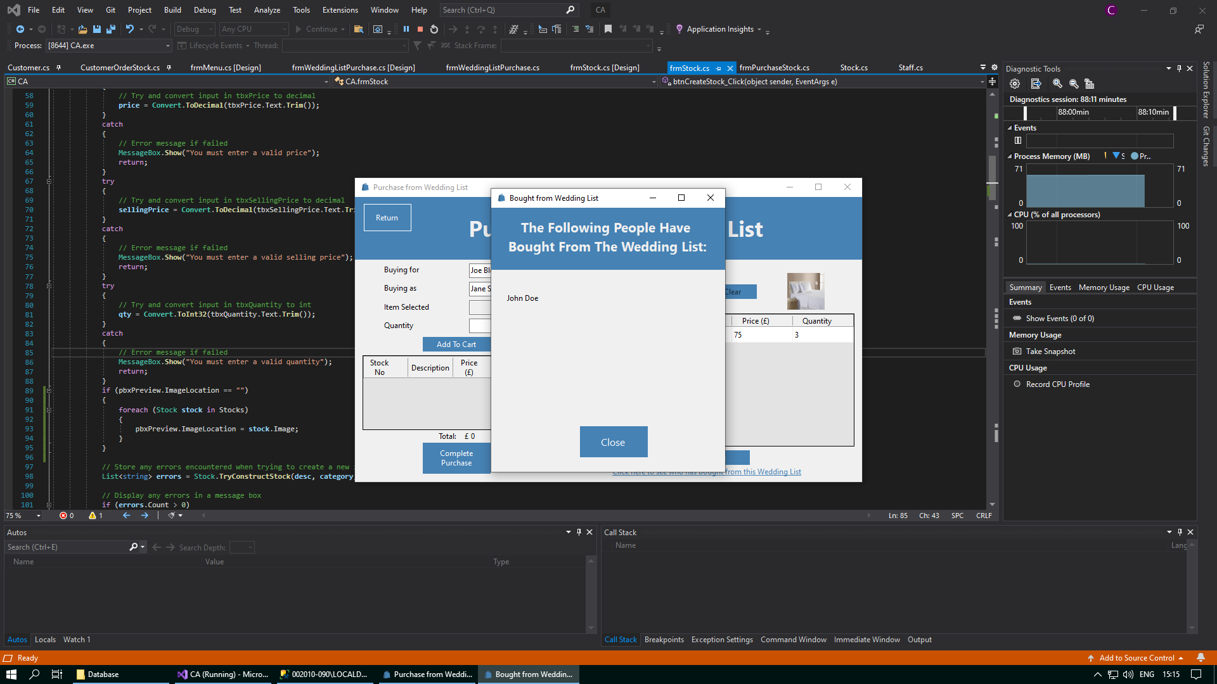

You can close this pop-up form by clicking the “Close” button.

# Further Help/FAQ

1. **Why must I reselect a customer to purchase stock if I have just made a customer order for them?** **Why can’t I be brought to the Purchase Stock form automatically?**

When purchasing stock for a customer who has not purchased stock before, you must click the “Create Customer Order” button. A message box that says “Customer Order successfully created” will be displayed. Now, you reselect this customer and click the same button again, which will now say “Purchase Stock”, to be brought to the Purchase Stock form. The reason for this is that when purchasing stock, a “Customer Order” will be first be made. This records details about the order that stock will be purchased for. This includes details such as delivery details and the date of the order. This is stored in the CustomerOrder table in the database. A new entry for the customer order made will be recorded in this table when the “Create Customer Order” button is clicked. You must then reselect the customer to be brought to the Purchase Stock form. Any stock purchased is recorded as “Customer Order Stock” in the CustomerOrderStock table in the database. When trying to make a new entry in the CustomerOrder table and bring the user to the Purchase Stock form in one click, the details for the new Customer Order are not passed over. To avoid this error, you must do this in two steps, to ensure that the details for the customer order are passed over.

1. **Why must I reselect a customer to add to their wedding list if I have just made a wedding list for them? Why can’t I be brought to the Wedding Stock form automatically?**

When creating a wedding for a customer who has not started a wedding list yet, you must click the “Create Wedding List” button. A message box that says “Wedding List successfully created” will be displayed. Now, you reselect this customer and click the same button again, which will now say “Update Wedding List”, to be brought to the Wedding List Stock form. The reason for this is that when purchasing stock, a “Wedding List” will be first be made. This records details about the wedding list that stock will be purchased for. This includes details such as a reference name and whether or not the wedding list has been marked as complete. This is stored in the WeddingList table in the database. A new entry for the wedding list made will be recorded in this table when the “Create Wedding List” button is clicked. You must then reselect the customer to be brought to the Wedding List Stock form. Any stock added to the wedding list is recorded as “Wedding List Stock” in the WeddingListStock table in the database. When trying to make a new entry in the WeddingList table and bring the user to the Wedding List Stock form in one click, the details for the new Wedding List are not passed over. To avoid this error, you must do this in two steps, to ensure that the details for the wedding list are passed over.

1. **Can I add the same item to the same wedding list multiple times?**

Yes! If you add an item of stock to a wedding list, and then later decide that more of this same item of stock is required to be added to this wedding list, you can do so easily in the Wedding List Stock form. When this wedding list is marked as complete, and then selected in the Wedding List Purchase as a wedding list to buy from, you will be able to see that this item will be displayed with its overall quantity. For example, say you added a microwave to a wedding list, and then you decide to add another microwave to the same wedding list. Whenever you select this wedding list in the Wedding List Purchase form, you will not see two microwaves listed, but instead only one microwave with a quantity of two.

1. **When creating a new item of stock, I forgot to select an image. However, no error was returned either. What happened?**

Whenever you create a new item of stock, and you do not select an image, there will be no warning to tell you that you didn’t select an image. If you select the new item of stock you just made from either the data grid view or the combo box, you will see that an image will have already been assigned to this item of stock. The image that was in the preview picture boxat the time of creation of the new item of stock serves as a default image until you update the item of stock with a new image. If there was no image in the preview picture box at the time of creation, then the image of the item of stock at the bottom of the data grid view will be used as the default image.

1. **When making a booking for a customer, I decide that I want to cancel making the booking. How can I do this?**

If you are making a booking for a customer, and you decide that you want to cancel making this booking, you can do so by clicking on the “Return” button. This will only cancel the booking if you have not already clicked the “Book” button yet. If you had selected a date and a time slot for the customer you were making a booking for, then this time slot on this date will still be available for other customers to book for. If you decide you want to try make a booking for this customer again, you can do so by selecting this customer in the data grid view in the Customer form, and then clicking the “Create a Booking” button.

1. **What happens if I do not mark a wedding list as complete?**

If you do not mark a wedding list as complete, then it will be assumed that this wedding list is incomplete, and you can still update this wedding list. However, when the day changes to tomorrow, you will no longer be able to see this customer in the data grid view in the View Bookings form, and so the creation of this wedding list will have been assumed to be abandoned if it was not marked as complete by the end of the previous day. This will result in the wedding list not being displayed in the Wedding List Purchase form to buy from.

1. **I have added an item of stock to my cart, but I no longer want to purchase this item (or add it to a wedding list). How can I delete this item from my cart?**

At the moment, the only way not to complete a purchase for an item of stock in the cart (or to not add it to a wedding list) is to click the “Return” button on the form you are currently on, and then return to this form. This will delete all the items in the cart and they will not have been purchased (or added to a wedding list). However, if there were other items of stock in the cart that you did want to buy, then you will have to readd this items to the cart as they also will have been deleted. The same method applies if you add a certain number of stock to the cart, but you want to purchase less (or add less to a wedding list). If you want to purchase more (or add more to a wedding list), all you have to do is add more to the cart.

1. **What happens if I purchase the entire quantity for an item of stock? Will this be deleted from the Stock table in the database?**

No – an item of stock is allowed to have a quantity of 0. If you purchase the entire quantity of an item of stock, and it now has a quantity of 0, then it will not be displayed in the data grid view in the Purchase Stock form or the data grid view in the Wedding List Stock form. However, it will still be displayed in the data grid view in the Stock form. When you select this item in the stock form, either using the combo box or the data grid view, a label will be displayed that says “OUT OF STOCK” in bold red text to tell you to order more of this stock in. When more of this stock is ordered in, you can update this in the Stock form. This item will its new quantity will now be displayed again in the data grid views in either the Purchase Stock form or the Wedding List Stock form.